**Oxfordshire County Council**

**Oxford City Council**

**Connecting Oxford:**

**Report of Engagement**

**November 2019**

**Executive summary**

Oxfordshire County Council and Oxford City Council launched their [Connecting Oxford](https://www.oxfordshire.gov.uk/residents/roads-and-transport/connecting-oxfordshire/connecting-oxford) proposals on 18 September 2019 and sought views from the public and stakeholders. The engagement period lasted until 20 October 2019.

All of the feedback has been analysed by the Connecting Oxford project team, however this report of engagement seeks only to summarise the feedback – with the complete dataset of responses retained should the Connecting Oxford strategy advance into the more detailed planning and design stage.

A copy of the Connecting Oxford questionnaire is provided at the end of this report.

**Key facts**

* A total of 2932 respondents completed and submitted the online survey.
* 95% of responses were completed in a personal capacity. The remaining 5% were completed on behalf of a business, employer or other organisation.

**Where do people live?**

* Most respondents lived within or immediately surrounding Oxford (OX1 to OX4 accounted for 64% of postcodes).
* The most frequently recorded postcode was OX2 - 22% of respondents.
* There were also clusters of respondents living in major Oxfordshire towns and villages including Thame, Faringdon, Chipping Norton, Kidlington and Henley-on-Thames.

**Gender and age**

* There were more female respondents (55%) than male respondents (45%).
* Just under half of the respondents who provided their age range were between 35-54 years old. This age range is also the largest in Oxfordshire, accounting for 40% of the population.

**Main travel purpose**

* 56% of respondents indicated that their main travel purpose was ‘commuting to and from work’. A further 1 in 4 respondents said their main travel purpose was shopping, leisure and tourism.

**Main mode of travel**

* 35% of respondents indicated that their main mode of travel was ‘car all the way to my destination’. 32% said ‘bicycle’. ‘Bus’ was selected as the main transport mode by 11% of respondents.

**Disability**

* 9% of respondents indicated that they have some form of disability.

**Views on Traffic restrictions**

*Those responding in a personal capacity*

* Overall, more of those responding in a personal capacity thought that the proposed traffic restrictions would make their journey worse (42%) than better (33%).
* For those respondents living in Oxford, 40% thought the traffic restrictions would make their journey worse and 39% thought they would be better.
* Views on traffic restrictions varied according to mode of travel:
  + 75% of those responding whose main mode of travel is car considered the traffic restrictions would make their journeys worse; 5% thought their journey would be ‘better’).
  + 25% of those responding whose main mode of travel is not car (or car for only part of their journey) consider that the traffic restrictions would make their journeys worse; 48% thought their journey would be ‘better’).
* Frequently stated reasons why people felt the traffic restrictions would make their journeys better were:

Better and safer cycling; better bus travel; less pollution and better air quality; reduced traffic and congestion

* Frequently stated reasons why people felt the traffic restrictions would make their journeys worse were:

Reduced access; longer journeys and increased costs; displacement of traffic and congestion; increased pollution and carbon emissions; lack and high cost of non-car alternatives, impact on local economy and jobs

*Those responding on behalf of an employer, business or other organisation*

* 53% of those responding on behalf of organisations indicated that proposed traffic restrictions would make transport in Oxford worse
* 26% indicated that the traffic restrictions would make transport in Oxford journeys better
* Frequently stated reasons why people representing an organisation felt the traffic restrictions would make their journeys worse were:

Congestion on alternative routes, possible difficulties with operational access, staff access and recruitment/retention concerns, worsening pollution where traffic is displaced and lack of public transport alternatives to existing car journeys that would be prevented

* Frequently stated reasons why people representing an organisation felt the traffic restrictions would make their journeys better were:

Reduced traffic and congestion, better walking and cycling provision, reduced pollution and better public transport provision

**Views on workplace parking levy**

*Those responding in a personal capacity*

* Overall, more of those responding in a personal capacity thought that the proposed workplace parking levy would make their journey better (36%) than worse (25%).
* For those respondents living in Oxford, 43% thought the workplace parking levy would make their journey better and 18% thought they would be worse.
* Views on the workplace parking levy also varied according to mode of travel:
  + Just under 50% of those responding whose main mode of travel is car considered the workplace parking levy would make their journeys worse.
  + 50% of those responding whose main mode of travel is not car consider that the traffic restrictions would make their journeys better; 12% felt that their journeys would be worse
* Frequently stated reasons why people felt the workplace parking levy would make their journeys better were:

Better bus travel; behaviour change; reduced traffic and congestion; better and safer cycling

* Frequently stated reasons why people felt the workplace parking levy would make their journeys worse were:

Increased cost of travelling/living; impact on economy and businesses; uncertainty over required improvements to public transport and other non-car modes; negative impact on people who need to use a car; possible displaced car parking.

*Those responding on behalf of an employer, business or other organisation*

* 34% of those responding on behalf of an organisation indicated that the proposed workplace parking levy would make transport in Oxford better
* 32% indicated that the WPL would make transport in Oxford worse
* Frequently stated reasons why people representing an organisation felt the workplace parking would make their journeys better were:

Better public transport, reduced traffic and better conditions for walking and cycling

* Frequently stated reasons why people representing an organisation felt the workplace parking would make their journeys worse were:

The impact of the local economy, staff access/recruitment and retention and lack of non-car travel alternatives

**Letter and email comments from stakeholders/organisations**

* 45 stakeholder groups submitted responses to the Connecting Oxford proposals either instead of or in addition to the online questionnaire. Of the very many comments made on the proposals, the most frequently raised were as follows:

General support for the objectives of Connecting Oxford

More information on proposals needed

Stakeholder input needed/offered as proposals develop

WPL area should cover further areas within the city

WPL could have an unfair impact on businesses

**Introduction**

Oxfordshire County Council and Oxford City Council launched their Connecting Oxford proposals on 18 September and sought views from the public and stakeholders. The engagement period lasted until 20 October and in total, 2932 online responses were received. Some further written feedback was received in emails and letters.

All of the feedback has been analysed by the Connecting Oxford project team, however this report of engagement seeks only to summarise the feedback – it does not go into detail on all of the feedback received (this report does not summarise the response to all questions, mostly for GDPR reasons).

There is a lot of detail provided in the feedback received and a wide range of opinion on the proposals. It is recognised that whilst this report summarising responses is very useful for observing patterns and themes, the complete dataset of responses needs to be retained and referenced for deeper analysis should the Connecting Oxford strategy advance into the more detailed planning and design stage.

A copy of the Connecting Oxford questionnaire is provided at the end of this report.

**About you and your organisation (Questions 1 – 17)**

All respondents to the online survey had the opportunity to complete questions about themselves, and where applicable, the employer, business or other type of organisation that they represented. The following provides a summary of responses.

**Question 1 - About you**

Out of 2932 online responses received, 95% were completed in a personal capacity. The remaining 5% were completed on behalf of a business, employer or other organisation.

**Question 6 - respondents’ home postcode**

A recognisable home postcode was provided by 2798 respondents (95%)

**Figure 1: Respondents’ home location postcode**

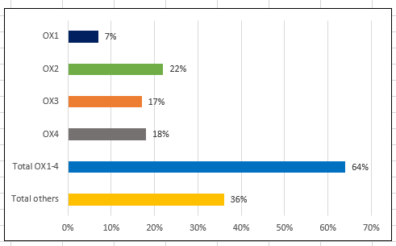

**Figure 2: OX1-4 postcode boundaries for reference**

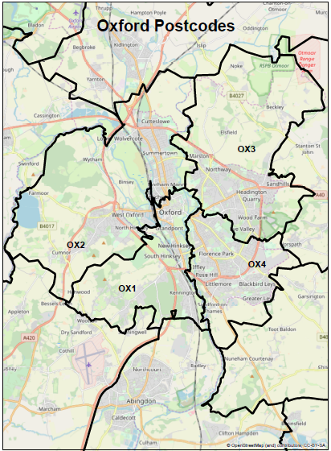

* Most respondents lived within or immediately surrounding Oxford as indicated by the home postcode provided (OX1-4 accounted for 64% of postcodes).
* The most frequently recorded postcode was OX2 (an area north and west of Oxford covering Cutteslowe, Summertown, Jericho, North Hinksey, Dean Court, Botley and Cumnor), with 22% of respondents providing this as their home postcode. Nevertheless, there is a good spread of responses from residents living across the city and in all areas likely to be affected by proposals (see Figure 4).
* There are also clusters of respondents living in other major Oxfordshire towns and villages including Thame, Faringdon, Chipping Norton, Kidlington and Henley-on-Thames (see Figure 3).

**Figure 3: Home postcode distribution across Oxfordshire (for respondents answering by online survey or email/letter)**

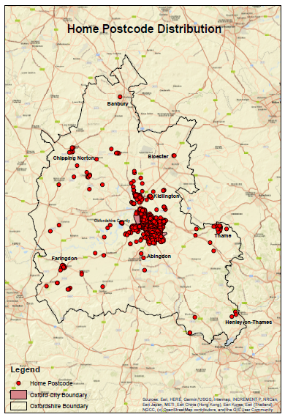

**Figure 4: Home postcode distribution across Oxford City (for respondents answering by online survey)**

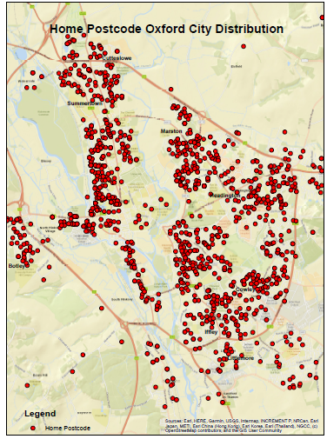

**Question 9 - respondents’ gender**

2035 respondents answered the question on their gender (69%). There were more female respondents (55%) than male respondents (45%).

**Question 10 - respondents’ age**

2033 respondents (69% of the total) answered the question on their age

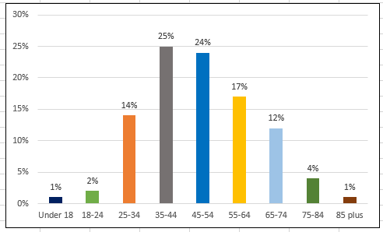**Figure 5: Respondent’s age**

Just under half of the respondents who provided their age range were between 35-54 years old. This age range is also the largest in Oxfordshire, accounting for 40% of the population (Office for National Statistics census data, 2011).

* The age range between 18-24 years is greatly underrepresented in survey responses at just 2% of the total. This compares to 20% of the Oxford total population falling in this age range, and 10% of the Oxfordshire countywide population.
* 39% of survey responses were from 25-44 years old compared to 32% of the Oxford population and 28% of the Oxfordshire countywide population.
* The age band between 45-64 years is overrepresented in the survey with 41% of survey responses between these ages compared to 18% of the Oxford population and 25% of the Oxfordshire countywide population.

**Question 14 - respondents’ disability status**

1874 respondents answered the question on disability (64%). Only 9% of respondents indicated that they have some form of disability.

**Question 19 - Respondents’ work location**

Only respondents who completed the online survey in a personal capacity were asked to provide a postcode of their normal place of work, if this was applicable. A recognisable work postcode was provided by 1556 respondents (53%).

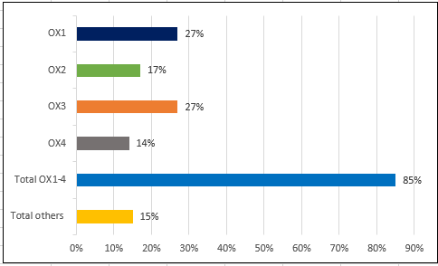**Figure 6: Respondents normal place of work by postcode**



* Most respondents providing a work postcode indicated that their normal place of work is within the area covered by postcodes OX1-4 (85%).
* Over half of respondents’ normal place of work is within the area covered by postcodes OX1 and OX3 (53%).
* There is a net outflow of respondents from areas covered by the OX2 and OX4 postcodes, with more respondents travelling from rather than commuting to these locations for their normal place of work (5% more travelling from OX2 and 4% more travelling from OX4).

**Figure 7: Normal place of work postcode distribution across Oxfordshire**

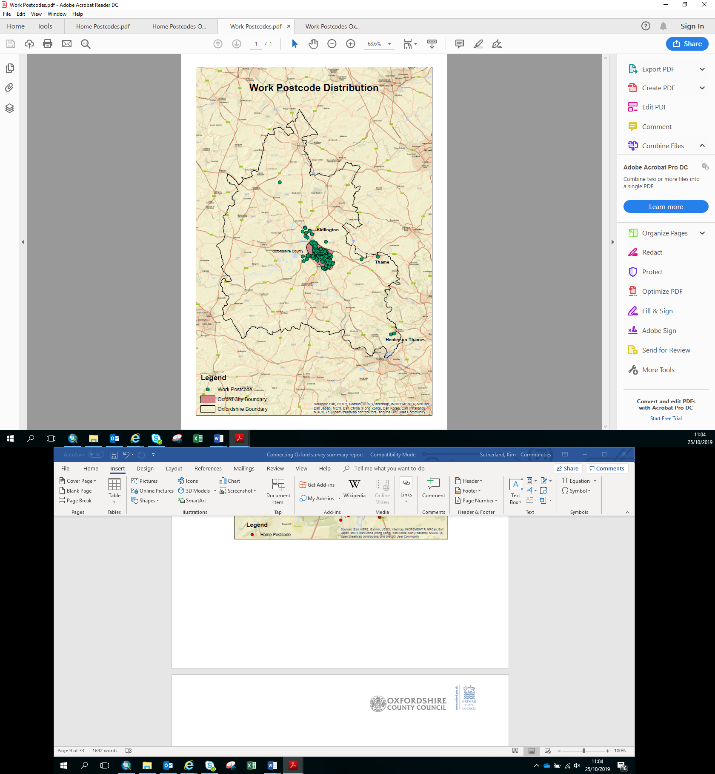

**Figure 8: Normal place of work postcode distribution across Oxford City**

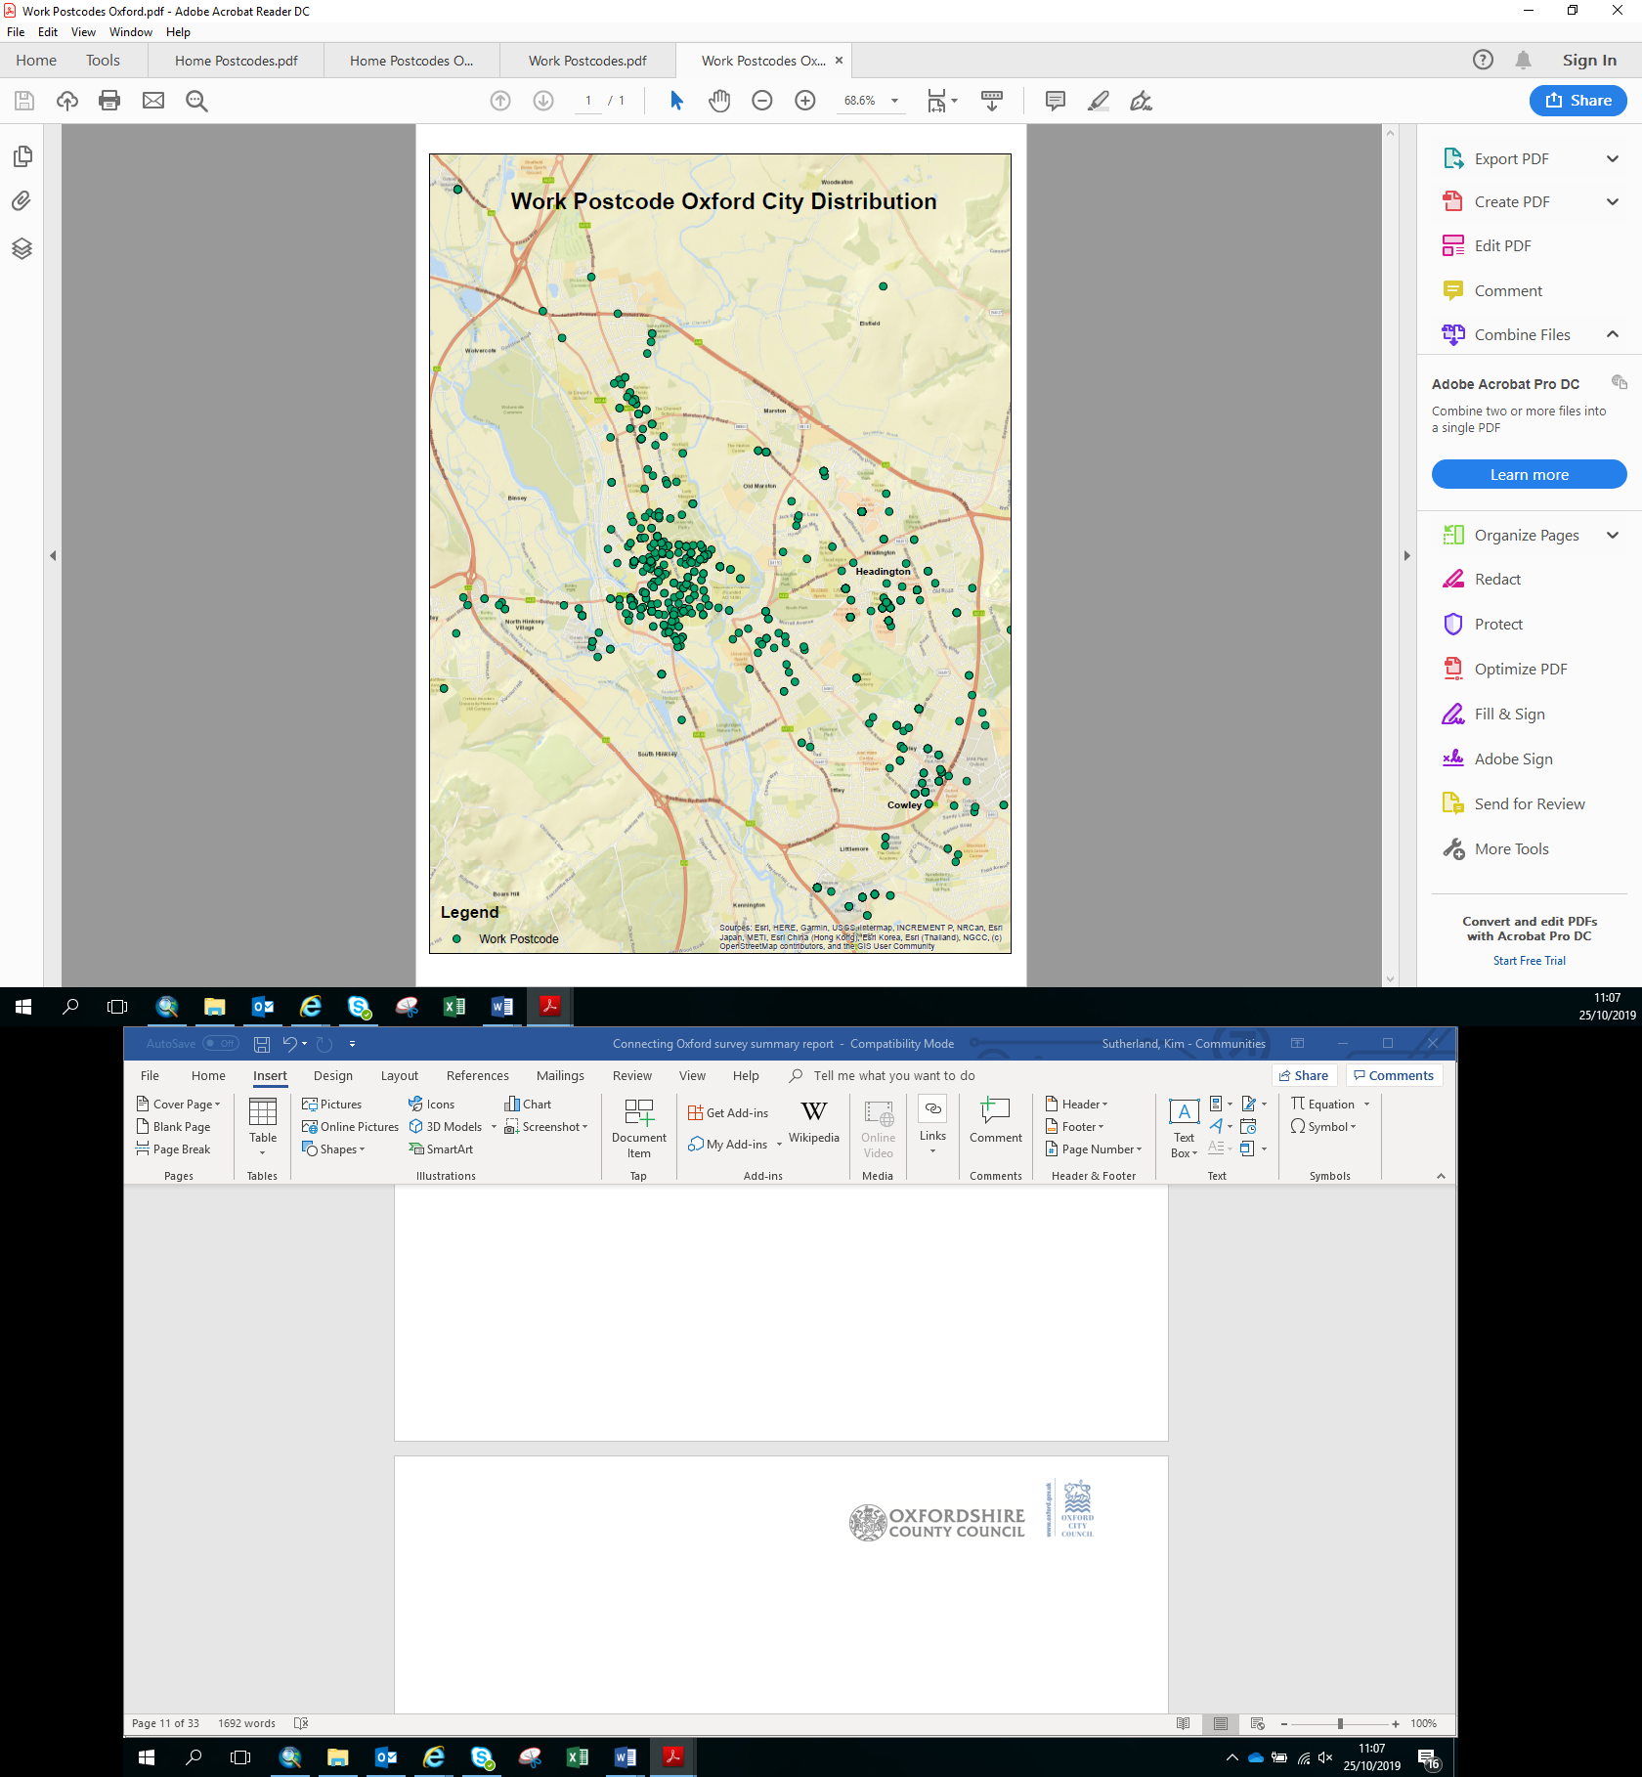

* Of the respondents who provided a postcode for their normal place of work within Oxford, most are in the centre of the city; reflecting the greater number of different employers/more discrete places of work in the city centre.
* The remaining work postcodes provided are mostly dispersed across Oxford’s Eastern Arc including in:
  + Headington- predominately at the hospital locations
  + Cowley- particularly the Mini plant and surrounding business parks

**Online survey responses from those responding in a personal capacity (Questions 18 – 22)**

The following section relates to respondents who answered questions and provided other feedback in a personal capacity only (2800 respondents).

**Question 18 - travel purpose**

2800 people answered this question (100% of those responding as individuals).

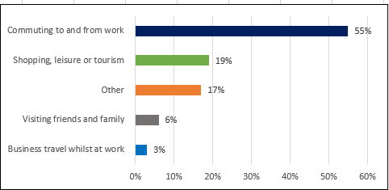**Figure 9: Travel purpose**

* Over half of the respondents indicated that their main travel purpose was ‘commuting to and from work’ (56%).
* Similar proportions of respondents indicated that they travelled for ‘shopping, leisure and tourism’ (19%) or ‘other’ purposes (17%).
* A small number of respondents selected ‘visiting friends and family’ (6%) and ‘business travel whilst at work’ (3%) as their main travel purpose.
* Of those who selected ‘other’, 5% of respondents mentioned the school run as part of or their sole journey purpose.

**Question 20 – how do you most often travel?**

2800 respondents answered the question on mode of travel for their main journey purpose in Oxford (100% of those responding as individuals).

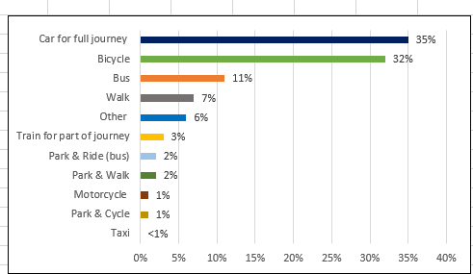**Figure 10: Mode of travel**

* Most respondents indicated that their main mode of travel was ‘car all the way to my destination’ (35%) or ‘bicycle’ (32%).
* ‘Bus’ was selected as the main transport mode by 11% of respondents.
* There was a relatively even distribution of respondents who ‘Park & Ride (bus)’ (2%), ‘Park & Cycle’ (1%) or ‘Park & Walk’ (2%).

**Question 22 – respondents’ priorities when travelling**

2595 of those who responded in a personal capacity (93%) answered the question requiring ranking of their three most important priorities when travelling in Oxford. Some responses could not be used in the analysis because the question was incorrectly answered including selecting more than three priorities.

**Figure 11: Top three important journey priorities for all modes of travel**

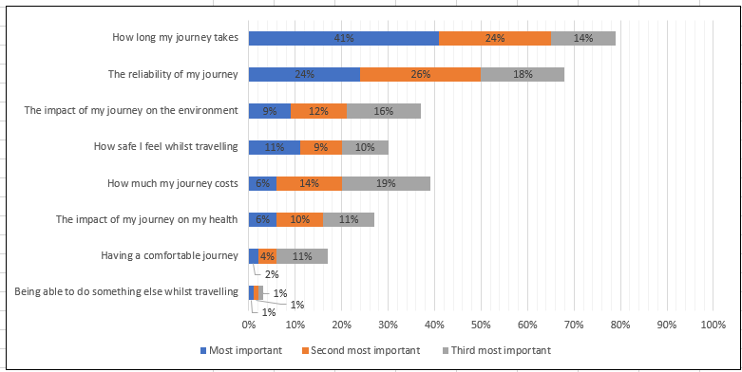

* ‘How long my journey takes’ is the option selected most often by respondents - 41% indicated that it was their most important priority, and a total of 79% selected this as either their most, second most or third most important priority.
* ‘The reliability of my journey’ is the next most common priority selected by respondents - 68% selected this as their most, second or third most important priority.
* ‘Being able to do something whilst travelling’ is selected the least by respondents - with only 3% choosing this as their most, second or third most important priority.

The following chart shows how priorities of respondents varies according to their main journey purpose in Oxford, so ‘car all the way to my destination’ or all other modes including a car for part of their journey such as ‘car & cycle’.

**Figure 12: Most important journey priorities by car only and all other modes**

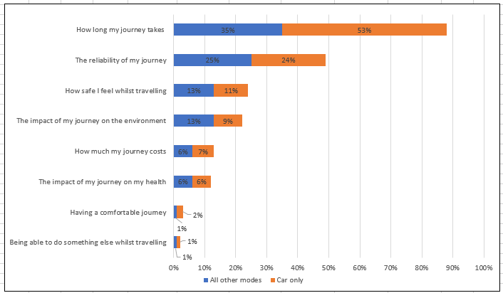

When separating out for those who travel by car only compared to those travel by all other modes journey priorities are still similar, with ‘*How long my journey takes*’ and ‘*The reliability of my journey’* the most important priorities.

* ‘How long my journey takes’ is the most selected priority, with 53% of car users and 35% of other mode users choosing this
* One quarter of other mode users selected ‘the reliability of my journey’ as most important (25%), with a similar proportion of car users choosing this priority (24%)
* ‘Being able to do something else whilst travelling’ is the least selected priority, chosen by only 1% of car users and 1% of other mode users

**Views on traffic restrictions (Question 23)**

**Question 23 – Views on whether traffic restrictions would make journeys better or worse overall**

All the 2800 people responding in a personal capacity answered the question on whether they thought traffic restrictions would make their journey better or worse overall, based on their journey priorities.

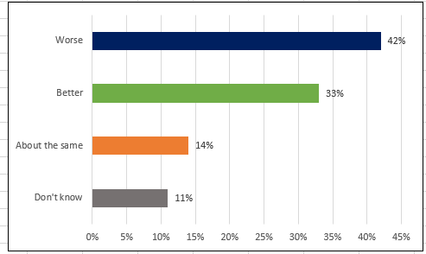**Figure 13: Personal views on traffic restrictions of all online respondents**

* More respondents thought that the proposed traffic restrictions would make their journey worse (42%) than better (33%).
* 14% of respondents did not perceive a change to their journey as a result of the traffic restrictions.
* 11% of respondents did not know the impact of proposed traffic restrictions on their journey.

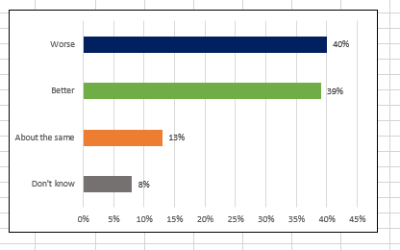**Figure 14: Personal views on traffic restrictions of all online respondents living in Oxford**

Compared to all respondents, fewer of those responding to the online questionnaire and stating an Oxford home postcode (OX1 to OX4), considered that the traffic restrictions would make their journeys worse (40%); more considered they would make their journeys better (39%). There were 1881 respondents (67%) who provided an Oxford postcode and answered this question.

The following chart shows how people’s views on the traffic restrictions varied by their main mode of travel in Oxford. All other modes included a car for part of the journey such as ‘car & cycle’.

**Figure 15: Personal views on traffic restrictions of all online respondents travelling by car only and all other modes**

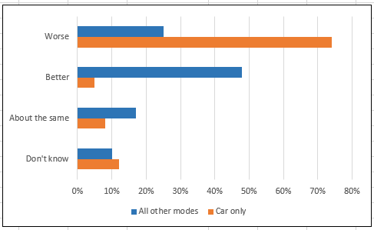

The traffic restrictions are viewed differently by different mode users – over 70% of respondents who travelled by car only for their main journey in Oxford thought that traffic restrictions would make their journey worse. This compared to only about 25% of those who used other modes including a car for part of their main journey. Just under 50% of respondents who selected other modes of travel indicated that their journeys would be better with the traffic restrictions

Respondents were subsequently asked why they thought their journey would be ‘better’, ‘about the same, ‘worse’ or ‘don’t know’ overall with traffic restrictions. A total of 2026 (70%) respondents left comments with a summary of the most common themes set out below.

*Traffic restrictions would make journey ‘better’*

|  |  |
| --- | --- |
| **Comment theme, in descending order of number of mentions** | **Summary of responses** |
| **Better and safer cycling** | Many respondents thought less traffic would make cycling safer, quicker and easier, including for and travelling with children.  Creating more space for segregated cycle lanes was welcomed, however, some respondents were concerned that this might not be fully realised.  There was also some concern that more buses could impact on cycle safety. |
| **Better bus travel** | Respondents linked less traffic with more reliable and quicker bus services.  Some respondents also wanted additional restrictions to speed up buses in places where no restrictions are proposed, for example, in the south east of the city. Other respondents thought that quicker buses would also improve air quality with fewer buses idling in traffic congestion. |
| **Less pollution and better air quality** | Respondents said reducing traffic would also improve air quality which would benefit everyone. |
| **Reduced traffic and congestion** | Respondents welcomed proposals that reduced traffic and congestion because this would directly benefit cyclists, pedestrians and bus travellers.  Some respondents commented that improvements to benefit cyclists, pedestrians and bus travellers need to be in place before the traffic restrictions are implemented. |
| **Healthier and safer travel including on foot** | Many respondents thought their journeys on foot would improve, particularly from better air quality and noise because of less traffic. Respondents thought this would mean healthier journeys. |

*Traffic restrictions would make journey ‘about the same’*

|  |  |
| --- | --- |
| **Comment theme, in descending order of number of mentions** | **Summary of responses** |
| **Unaffected by proposals** | Respondents thought that they would not be affected by the traffic restrictions including any potential impacts or benefits. Reasons including living, working or travelling outside areas directly affected including areas to the west (incl. Botley), east and south east of the city.  Some respondents also thought their mode of travel would be unaffected including those that use a train or who also travel by bus, on foot or bicycle within or to the city. |
| **Unsure of the benefits and impacts** | Some respondents were sceptical that traffic levels could be reduced and/or whether benefits could be realised.  Others were also unsure whether there would be benefits beyond the city centre and Oxford’s eastern arc, giving Abingdon Road, Botley Road, Cowley Road and Iffley Road as examples. |
| **Proposals won’t address all problems or don’t go far enough** | Some respondents wanted additional traffic restrictions and/or for impacts to benefit the whole city.  Some respondents also thought that there was a lack of vision and more could be done to improve walking, cycling and bus travel, for example.  Others thought proposals ignored traffic congestion caused by the school run and leisure and shopping trips. |
| **Proposals would benefit some modes but could negatively impact others** | Respondents could see benefits to some modes - bus and cycle - but disbenefits to others, including car travel. Respondents were concerned about residents’ access, with the traffic restrictions on Marston Ferry Road and Hollow Way mentioned several times in relation to this. |
| **Displacement of traffic &/or congestion** | Respondents felt that traffic might reduce in some areas, including the city centre, but were concerned that it would not reduce or could even increase in other areas, particularly those further away from the restrictions including areas to the west (incl. Botley), south and south east of the city.  There was particular concern about knocking traffic onto already congested roads. This included the ring road and approaches to the city e.g. A34, A40. |

*Traffic restrictions would make journey ‘worse’*

|  |  |
| --- | --- |
| **Comment theme, in descending order of number of mentions** | **Summary of responses** |
| **Reduced access** | Respondents were concerned about their ability to continue travelling to work, school, shops and other destinations. Concerns included travelling with young children or a member of the family or friend who has a disability or mobility issue, carrying heavy goods and linked journeys e.g. combining the school drop off with the commute to work.  Respondents living near the restriction(s) were particularly concerned about access to their homes but also to surrounding shops, schools and GP surgeries and other local services/facilities. Some also felt that restrictions could impact on social relations. |
| **Longer journeys & increased transport costs** | Respondents felt that restrictions would increase the length of journeys resulting in additional time and cost of travelling. Those who car share and who might also be affected by the WPL were concerned that it would impact on incomes. |
| **Displacement of traffic & congestion** | Concern that traffic would displace to strategic (ring road and approaches) and local roads (including residential streets) and that this would lead to more congestion and poor air quality in those areas. |
| **Increased pollution & carbon emissions** | Concern that restrictions would mean people driving further which would increase pollution in certain areas and lead to more carbon emissions overall. |
| **Lack & high cost of non-car alternatives** | Respondents, whether they lived in the city or travelled from outside, felt alternative transport options were limited and therefore not viable. Respondents living outside the city thought their options were further reduced with walking and cycling being completely out of scope.  Linked to this, respondents felt that improvements to public transport would need to be implemented before traffic restrictions were in place.  The cost of public transport, particularly bus services and paying for Park & Ride parking, was felt to be expensive and so travelling by car in comparison was considered cheaper. |
| **Impact on local economy & jobs** | Some respondents were concerned that restrictions could impact on jobs and the economy, with reduced access and/or additional travel costs affecting whether people or businesses would want to continue working or operating here. Many respondents cited the already high cost of living in or travelling to Oxford as a reason for their concern. |
| **Impact on those with disabilities and/ or other health related issues which impact on mobility** | Respondents were concerned about how they would be able to continue travelling to and around the city with restrictions in place. This included those who were disabled or who care for a family member or friend with reduced mobility or other health problems. There was concern that alternatives – bus, cycle and walk – would not be viable options. Many of these respondents saw their access to a car, even for occasional journeys, as being essential. |

*‘Don’t know’ whether traffic restrictions would make journey ‘better’, ‘about the same’ or ‘worse’*

|  |  |
| --- | --- |
| **Comment theme, in descending order of number of mentions** | **Summary of responses** |
| **Unclear of the proposals’ impact or of the changes being proposed** | Many respondents were unclear of the proposals benefits and impacts either because they felt there was not enough detail or because they were unclear as to what was being put forward and how it might affect the area they live in or journey they made, for example.  Many respondents thought there could be benefits, certainly in some areas, but also impacts in others and so wanted to see further analysis of the proposals to make a more informed decision. |
| **Reduced access** | Those respondents who chose ‘don’t know’ were also concerned about their ability to continue travelling to work, school, shops and other destinations, and the impact traffic restrictions could have on even occasional car journeys. |
| **Displacement of traffic & congestion** | There was also concern and uncertainty about traffic displacement particularly to residential streets but also the ring road and A34, albeit to a lesser extent. Concerns raised included moving congestion and pollution to other streets. |
| **Whether non-car alternatives would be in place in advance and whether these would be sufficient** | Some respondents were unsure whether non-car alternatives would be in place in advance, with many saying they should be particularly improved bus services. Several respondents mentioned the cost of bus travel and lack of bus services as a reason for not choosing these modes currently. |

**Views on a workplace parking levy (Question 24)**

**Question 24 – Views on whether workplace parking levy would make journeys better or worse overall**

All of the 2800 people responding in a personal capacity answered the question on whether they thought the workplace parking levy would make their journey better or worse overall, based their journey priorities.

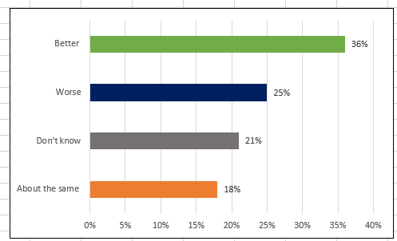**Figure 16: Personal views on workplace parking levy of all online respondents**

* More respondents believed that the workplace parking levy would make journeys better (36%) than worse (25%).
* The workplace levy is viewed more positively than the traffic restrictions (see Figure 13) by those responding in a personal capacity- 3% more believe that the workplace levy will be better and 17% less indicated their journey would be worse.
* A notable proportion of respondents did not know what impact the workplace levy would have on their journey (21%). This is about twice as many as said they didn’t know the impact that the traffic restrictions would have on their journeys (see Figure 13).

**Figure 17: Personal views on workplace parking levy of all online respondents living in Oxford**

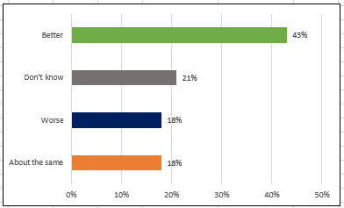

Compared to all respondents, more of those responding to the online questionnaire and stating an Oxford home postcode (OX1 to OX4), considered that the workplace parking levy would make their journeys better (43%); fewer considered they would make their journeys worse (18%). There were 1881 respondents (67%) who provided an Oxford postcode and who also responded to this question.

The following chart shows how respondents’ views about the effect of the proposed workplace parking levy varies according to the main mode of travel. Again, all other modes included a car for part of the journey such as ‘car & cycle’.

**Figure 18: Personal views on workplace parking levy of all online respondents travelling by car only and all other modes**

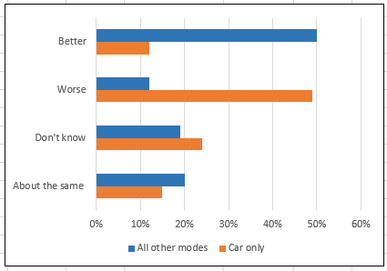

As with views on the traffic restrictions (see Figure 15), the impact on people’s journeys of the workplace parking levy is viewed differently according to mode:

* Almost half of respondents who selected ‘car all the way to destination’ indicated that the workplace parking levy would make their journeys worse; 12% indicated that they would be better.
* 50% of respondents who selected other modes of travel, including a car for part of the journey, indicated that their journeys would be better, whilst 12% indicated that it would be worse.
* A notable proportion of residents indicated they did not know the impact the workplace parking levy would have on their journey (‘car all the way to destination’ 24%; other modes 19%).

Respondents were subsequently asked why they thought their journey would be better or worse overall with a workplace parking levy. A total of 1707 (58%) respondents left comments with a summary of the most common themes raised given below.

*A workplace parking levy would make journey ‘better’*

|  |  |
| --- | --- |
| **Comment theme, in descending order of number of mentions** | **Summary of feedback** |
| **Better bus travel** | Respondents thought they would benefit from both new and improved bus services as well as quicker journeys and better reliability.  Some respondents thought that if bus services were more reliable and cheaper this would make them change their travel behaviour.  The need for more Park & Ride capacity, as well as free or cheaper parking at Park & Ride sites, was also raised frequently. |
| **Behaviour change** | Respondents thought the WPL would bring about a change in behaviour. Either encouraging employers to reduce the amount of car parking they provide or nudge staff to use public transport, walk or cycle to work.  Some respondents thought however that the charging level would need to be higher to make a real difference. |
| **Reduced traffic and congestion** | Reduced traffic was mentioned frequently, with WPL and investment in non-car modes helping to reduce traffic and congestion.  Some respondents linked traffic reduction with road space reallocation, particularly for cycling. |
| **Better and safer cycling** | Respondents thought cycle journeys would improve from less traffic but also from investment in cycle infrastructure. |

*A workplace parking levy would make journey ‘about the same’*

|  |  |
| --- | --- |
| **Comment theme, in descending order of number of mentions** | **Summary of feedback** |
| **Journeys not affected** | Some respondents thought their journey would be unaffected because they travelled or worked outside the proposed WPL area. This included those living or working in areas in the west of Oxford city.  Others thought that their mode of travel would be unaffected including those who walk, cycle and use the train. |
| **Impact on local economy** | Respondents thought it was another tax and could impact on the local economy. Some thought this could be overcome if there was real improvement in alternatives. Whilst others were concerned of the potential impact on those on low incomes, with those working at the hospitals and schools mentioned often. |
| **WPL area should be enlarged** | Some thought the WPL area should include the city centre and/or areas beyond the ring road. Respondents thought proposals didn’t go far enough if these areas were excluded. |
| **No impact in reducing traffic** | Respondents thought the WPL would make no difference - either because the WPL area was not large enough or because employers or employees would continue to pay the levy and not reduce parking or change travel behaviour. |

*A workplace parking levy would make journey ‘worse’*

|  |  |
| --- | --- |
| **Comment theme, in descending order of number of mentions** | **Summary of feedback** |
| **Increased cost of travelling/living if the charge was passed onto employees** | Respondents were concerned that the levy would be passed on to them or other employees and the impact this could have on finances, particularly those on low incomes. Some respondents indicated that they already pay for parking at their workplace. The already high cost of living in Oxford and Oxfordshire was also mentioned by some respondents.  Some respondents also questioned the fairness given it would only impact on those working in the Eastern Arc of Oxford. |
| **Impact on economy and businesses** | Respondents were also concerned about the negative impact of a WPL, particularly on employers and businesses, and the potential impact this could have on discouraging businesses from Oxford and adding to ongoing challenges around recruitment and retention of staff.  There was also concern that businesses might relocate out of the WPL area to other parts of the city or county.  Other respondents thought it was another tax on businesses. |
| **Improve public transport and alternative methods of transport** | Respondents felt that changes (both WPL and traffic restrictions) should not be made until public transport and alternative methods of transport, such as walking and cycling, were significantly improved.  There was also concern about there being adequate capacity to cope with future demand for bus services and Park & Ride. |
| **Impacting on those who need a car** | Respondents felt they or other people needed parking due to a lack of viable alternative methods of transport or needing flexible transport from a personal perspective or employment circumstances e.g. travel for business during their time at work. |
| **Impact of displaced car parking** | Respondents thought this might encourage people to park in nearby streets which would impact on residents in terms of increased traffic, congestion & pollution. |

*‘Don’t know’ if a workplace parking levy would make journey ‘better or worse’*

|  |  |
| --- | --- |
| **Comment theme, in descending order of number of mentions** | **Summary of feedback** |
| **Unaffected by WPL** | Many respondents indicated that they would be unaffected by proposals either because they don’t commute to a place of work in Oxford’s Eastern Arc or are self-employed or retired, for example.  Some respondents also thought they would not benefit from improvements either because they did not travel in Oxford’s Eastern Arc or because they were unsure if funding would be used to improve their favoured mode of travel. This included those living in areas outside the levy both within and outside Oxford. |
| **Unsure of impact** | Some respondents were unsure whether the WPL would reduce traffic and/or raise enough income to fund alternatives.  Some respondents were also unclear what a WPL was and whether they or their employer would be affected. |
| **Further detail required** | Respondents wanted more information on proposals and their impacts. Without this information some respondents said they could not make an informed opinion on the impact of the WPL. This included knowledge on income it could raise and alternatives it would fund.  Linked too this, many respondents felt alternatives need to be provided in advance including better & cheaper bus services and Park & Ride. |
| **Unfair** | Respondents thought a WPL was unfair on those it affected including employers, employees, those on low incomes, those who said their job or personal circumstances required travel by car or where no alternative mode of travel is or would be available.  Some respondents also thought it was unfair to only include part of the city within the WPL proposal. |

**Ideas for Other Changes (Questions 25 – 29)**

**Question 25 – Could anything else be done to improve your journeys in Oxford**

All of those responding in a personal capacity (2800) answered this question based on their priorities and most respondents indicated that something else could be done to improve their journey.

Many replies covered more than one aspect for suggested improvement. Figure 19 plots the 10 most frequently requested improvements. The chart shows how people’s main mode of transport influenced the suggestions for improvements that were made.

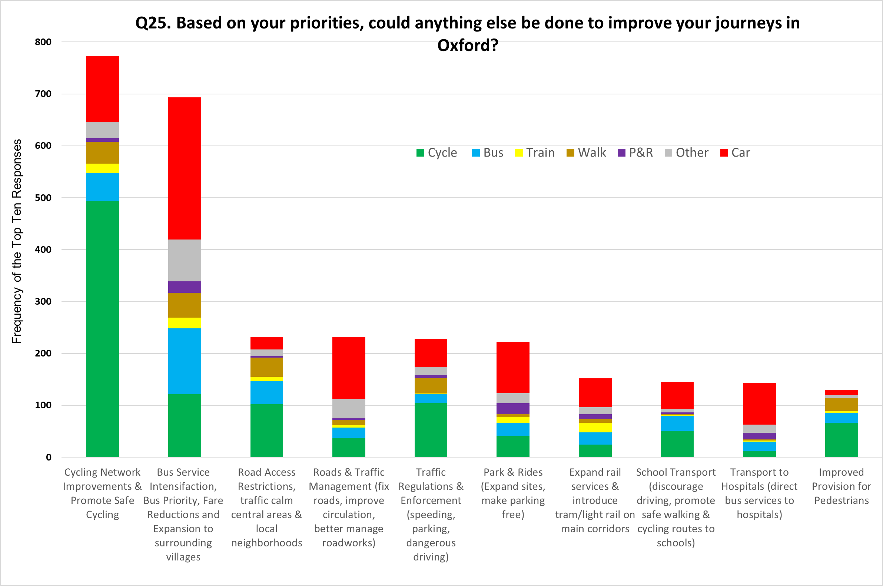

**Figure 19 – what else can be done to improve your journey in Oxford?**

Two categories of replies made up 50% of all responses for suggested improvements, namely:

* Expand and enhance segregated and continuous cycling routes and promote safe cycling (26% of all suggestions) – mainly mentioned by those whose main mode of transport is cycle but also mentioned by those whose main mode is car, bus or walk.
* Comprehensive bus service improvements including new routes and expansions to serve surrounding villages, increasing priority for buses in traffic and a reduction in fares (24% of all suggestions) – mainly mentioned by those whose main mode of transport is car, but also by those whose main mode is bus, cycle or walk.

After the top two responses, there were four categories for suggested improvements all with a similar frequency of response namely:

* Further road access restrictions, traffic calm central areas and local neighbourhoods.
* Roads & traffic management (fix roads, improve circulation, better manage roadworks).
* More and better enforcement of Traffic regulations – e.g. speeding, parking, dangerous driving.
* Park & Rides - expand sites, make parking free, fares cheaper.

**Online survey responses from those responding on behalf of an employer, business or other organisation (Questions 26 – 29)**

132 responses were received online from people representing an organisation, on behalf of 119 identifiable organisations (some organisations submitted several responses, and in some cases, it was not possible to identify a specific organisation from the response).

These 119 organisations are listed below.

*St Christopher's Primary School, Seeing Eye Productions Ltd, Adrian James Architects, Newtrim (UK) Limited, Pure Offices, Pamoja Education Ltd, Regus, The Dog House, Hollow Way Medical Centre, Headington Quarry School, Oxfordshire Transport & Access Group, Heather House B&B, Martin & Co, Oxford, MTDB Ltd t/a Common Ground, Colourful Coffins, Tyndale Community School, Oxford High School, Railfuture, Thames Valley Branch, St Anne's College, Indigo - shop on the Cowley Road, Cowley Parish Church of England, Summer Fields School, Oxbotica, Oxwash Limited, BMW (UK) Manufacturing Ltd, Basil Wyatt Holdings Ltd and Basil Wyatt Property Ltd, Kennington Parish Council, City Primary School, Risk Decisions Ltd, St Clare's Oxford, City of Oxford Licensed, Christ Church, Oxford Health NHS Foundation Trust, Employee of the John Radcliffe Hospital, Summertown Health Centre, Mobike, Zzoomm plc, St Christopher's Primary School, Cowley, Oxford Fertility, Arriva, Observatory Medical Practice, Visual Meaning Ltd, Bartlemas Surgery, L'altreVi Ltd, Zeta Specialist Lighting, River Hotel, CBT Oxford Ltd, Abingdon Town Council, BBOWT, Yogavenue, Gray Baynes and Shew LLP Architects and Surveyors, Linacre College, Oxford, Corpus Christi College, St Lukes Radiology Oxford Ltd, New College, Instruments of Time and Truth, Oxford Equity Group, Climate Organization, S Hutchins & Green Ltd, Freight Transport Association, Bright Properties, Oxford Harmonic Choir, Wolfson College, University of Oxford, Branca, Marston Ferry and Blackhall Allotment Society, St Michael's C of E Primary School, Oxford, OX3 0EJ, VSL and Parnters Ltd, North Hinksey Parish Council, New Marston Primary School, Mail Boxes Etc., R & G Building Services (Oxford) Ltd, Joe's Restaurant in Summertown, John Wiley & Sons ltd, Urwin (Oxford) Ltd trading as Martin & Co, Oxford, Stovely Chimney Sweep and Stove Servicing, Oxford Bus Company and Thames Travel, St Edward's School, Driving instructors, BongoIT, Babylon Trading, Frog Orange, Matthew Clulee hair spa, St Gregory the Great Catholic School, Isis Creative Framing, Jennifer Tanner Ltd, Beckley and Stowood Neighbourhood Plan Steering Group, New College School, Goring & Streatley Transport Office, Oxford University Hospitals NHS Foundation Trust, Keble College, Oxford West End Development Limited, Residents' Association for Elsfield Road and Oxford Road, Old Marston, Oxford Preservation Trust, The Swan School, Bodleian Packaging and Delivery Service, University of Oxford, Jeremy Jones Associates, Oxford Business Park, Rose Hill and Iffley Low Carbon, 19 Beaumont Street Surgery, Oxford, Bodleian Libraries, University of Oxford, J & M Insulations Limited, South Jericho Residents' Association, Oxford Brookes University, Old Marston Parish Council, The Cherwell School, Oxfordshire Clinical Commissioning Group, Council of Oxfordshire Teacher Organisations, Oxford City Liberal Democrats, Sharp Laboratories of Europe Ltd., Harwell Campus Bicycle Users Group, Oxford Friends of the Earth, Oxfordshire Neighbourhoods & Villages Trust Ltd, Broken Spoke Bike Co-op, General Practitioners (practice not specified), CPRE Oxfordshire, Oxford Health NHS Trust, Bus Users Oxford, The Oxford Food Company Ltd, Cycling UK*

**Question 26 – what are your organisation’s top three priorities for transport in and around Oxford?**

All respondents answering on behalf of a business or organisation answered the question requiring ranking of the three most important priorities for staff commuting to and from work, business travel (excluding commuting) and movement of goods and service vehicles. Some responses could not be used in the analysis because the question was incorrectly answered including selecting more than three priorities.

**Figure 20: Top three most important journey priorities**

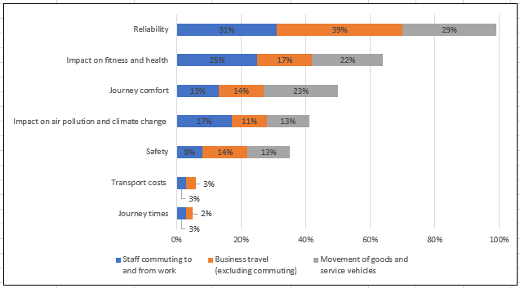

* Regardless of journey purpose, priorities are ranked similarly - ‘reliability’ is the most important priority followed by ‘impact on fitness and health’
* ‘Journey times’ and ‘transport costs’ are considered least important, with these priorities not selected under ‘movement of goods and service vehicles’

**Question 27 – Does the organisation think traffic restrictions will make transport in Oxford better or worse overall?**

All 132 respondents representing an organisation answered the question on would the proposed traffic restrictions make transport in Oxford better or worse overall.

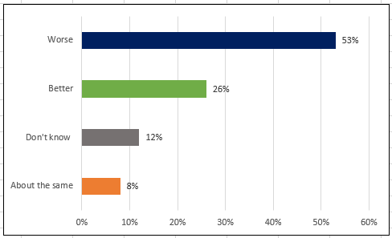**Figure 21: Views on traffic restrictions of businesses, employers or organisations**

* Over half of businesses, employers or organisations responding online indicated that the proposed traffic restrictions would make their journeys worse (53%).
* Just over one quarter of businesses, employers or organisations responding online indicated that the proposed traffic restrictions would make journeys better for their organisation (26%).
* 11% more respondents believed that the traffic restrictions would have a negative impact on their organisation compared to those responding to the survey in a personal capacity (see Figure 13).

Respondents commented on why they answered the way they did with a summary of the most common themes raised given below.

*Traffic restrictions would make transport in and around Oxford ‘better’ overall*

|  |  |
| --- | --- |
| **Comment theme, in descending order of number of mentions** | **Summary of feedback** |
| **Reduced traffic & congestion** | Respondents felt that traffic restrictions would be effective in reducing traffic and congestion levels in the city, with linked benefits for cycling, walking, pollution and public transport connectivity.  Respondents also felt that the traffic restrictions would boost the number of people walking and cycling. |
| **Better cycling/walking** |
| **Reduced pollution** |
| **Better public transport** |

*Traffic restrictions would make transport in and around Oxford ‘about the same’ overall*

|  |  |
| --- | --- |
| **Comment theme, in descending order of number of mentions** | **Summary of feedback** |
| **Congestion on alternative routes** | Concerns that the traffic restrictions would simply transfer traffic to other routes in and around the city, causing congestion and pollution problems elsewhere, achieving no overall benefit |
| **Travel habits hard to change** | Concern that the measures proposed would be insufficient to change ingrained travel habits |
| **Experience from London** | Concern that London congestion charge has not achieved significant overall improvements |

*Traffic restrictions would make transport in Oxford ‘worse’ overall*

|  |  |
| --- | --- |
| **Comment theme, in descending order of number of mentions** | **Summary of feedback** |
| **Congestion on alternative routes** | Concerns that the traffic restrictions would simply transfer traffic to other routes in and around the city, causing congestion and pollution problems elsewhere, and making the overall situation worse. |
| **Operational access** | Concerns that the traffic restrictions would cause difficulties for operational transport required for organisations to function, such as staff travel while at work, deliveries, servicing, visiting patients or clients.  In many cases respondents felt these operational trips could not be easily made by other modes and could not be easily made using alternative routes. There were some exemptions suggested to allow for operational access requirements. |
| **Staff access/recruitment & retention concerns** | Concern that the traffic restrictions would increase the time and cost for staff commuting to work, and that this would in turn make recruitment and retention of skilled staff more challenging. |
| **Pollution** | Linked to the first point above, concern that the traffic restrictions would i) displace traffic to other areas and increase pollution in those areas; and ii) increase emissions and pollution overall due to longer distances travelled by diverted traffic. |
| **Lack of public transport alternatives** | Concern that suitable public transport options are not available for staff, patients, visitors or customers who would be affected by the traffic restrictions. |

*‘Don’t know’ if traffic restrictions would make transport in and around Oxford better or worse overall*

|  |  |
| --- | --- |
| **Comment theme, in descending order of number of mentions** | **Summary of feedback** |
| **Mixed views** | These respondents saw both advantages and disadvantages, so felt they were unable to assess the overall impact |
| **Need more evidence** | These respondents felt they needed more information before they could assess the overall impact. |

**Question 28 – Does the organisation think the workplace parking levy and the improvements it will pay for will make transport in Oxford better or worse overall?**

All 132 respondents representing an organisation answered this question.

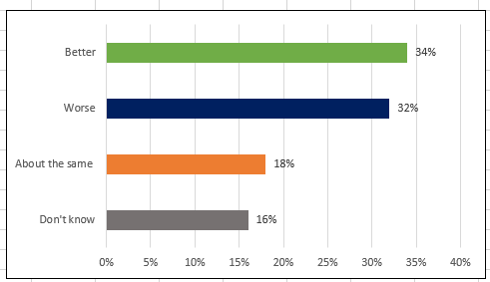**Figure 22: Views on workplace parking levy of businesses, employers or organisations**

* About a third of businesses, employers or organisations responding online indicated that a workplace parking levy and the improvements it would pay for would make transport in and around Oxford ‘better’ (34%). A similar proportion also indicated that it would make transport ‘worse’ (32%).
* Nearly 1 in 5 indicated that transport would be ‘about the same’ (18%).

From their organisation’s perspective, respondents were subsequently asked why they thought transport in and around Oxford would be ‘better’, ‘about the same’, ‘worse’ or ‘don’t know’ as a result of the proposed workplace parking levy. A summary of the most common themes raised is given below.

*The workplace parking levy would make transport in and around Oxford ‘better’ overall*

|  |  |
| --- | --- |
| **Comment theme, in descending order of number of mentions** | **Summary of feedback** |
| **Better public transport** | Respondents felt funds from the WPL would allow public transport to be improved, and would encourage commuters to use public transport |
| **Reduced traffic** | Respondents thought the WPL would reduce traffic in the city |
| **Better cycling/walking** | Respondents felt the WPL could fund cycling and walking improvements and that it would encourage commuters to use non-car modes. |

*The workplace parking levy would make transport in and around Oxford ‘worse’ overall*

|  |  |
| --- | --- |
| **Comment theme, in descending order of number of mentions** | **Summary of feedback** |
| **Impact on local economy** | View that the WPL is simply an additional tax on employers. Some who viewed the WPL in this way did not believe that transport improvements would be delivered, and/or felt that the improvements identified were insufficient to provide an overall transport benefit. |
| **Staff access/recruitment & retention concerns** | View that the WPL will make working in the area less attractive for staff and so cause employers to relocate away from Oxford, with consequences for the city’s economy, with no overall transport benefit. |
| **Lack of alternatives** | Concern that alternatives to the car are insufficient, so scheme will not achieve a mode shift and will therefore provide no overall transport benefit. |

*The workplace parking levy would make transport in and around Oxford ‘about the same’ overall*

|  |  |
| --- | --- |
| **Comment theme, in descending order of number of mentions** | **Summary of feedback** |
| **Staff access/recruitment & retention concerns** | Concerns that the WPL would have to be passed on to staff (because the organisation could not afford to pay it) and that this would make it harder to recruit and retain skilled staff. |
| **Impact on local economy** | View that the WPL is simply an additional tax on employers. Some who viewed the WPL in this way did not believe that transport improvements would be delivered, and/or felt that the improvements identified were insufficient. |
| **Cost** | Concern that the WPL would impose additional costs on employers. |
| **Employers will relocate away from Oxford** | View that the WPL will cause employers to relocate away from Oxford, with consequences for the city’s economy. |

*Respondents didn’t know what impact the workplace parking levy would have on transport in and around Oxford overall*

|  |  |
| --- | --- |
| **Comment theme, in descending order of number of mentions** | **Summary of feedback** |
| **No impact on organisation** | Respondents felt their organisation would not be affected by the WPL so did not wish to comment on the overall impact. |
| **Need more evidence** | These respondents felt they needed more information before they could assess the overall impact. |

**Responses to more detailed questions (Q30-39)**

The responses to the more detailed questions include comments from those responding in a personal capacity as well as those responding on behalf of a business, employer or other organisation. Two thirds of all respondents continued with the survey to answer the more detailed questions. A summary analysis for these questions is set out in the sections below.

**Q31. Should there be any exemptions for the traffic restrictions?**

1699 people (58% of all responses) provided feedback on this question.

Figure 23 plots responses by most common types of suggested exemptions. The exemption to the proposed traffic restrictions most frequently requested were vehicle trips undertaken by mobility impaired / disabled persons. This was followed by exemptions for residents and then travel for hospital staff, medical workers, care givers & health patients. It was suggested that these are essential and urgent trips not possible by public transport.

60 responses stated that taxis and private hire vehicles should not be exempt from traffic restrictions due to concern about the excessive number of such vehicles plying for hire in the central city area.

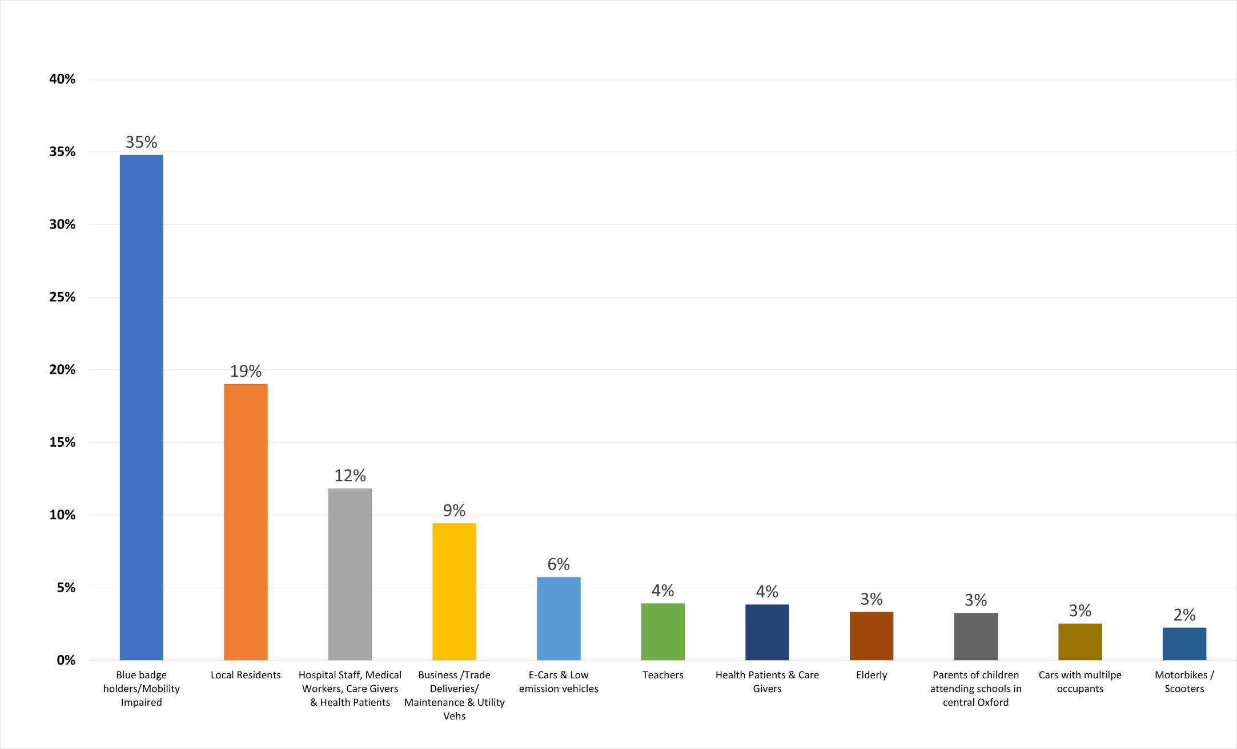

**Figure 23 – suggestions for exemptions for traffic restrictions**

**Q32. At what times and on which days should the traffic restrictions be in force?**

1630 people (56% of all responses) answered this additional question. Figure 24 shows the categorised responses. The highest number of responses (28%) stated that restrictions should be in place on Monday to Friday during peak periods only, when the traffic levels are at their highest. The second highest number of responses (21%) called for restrictions to be in place 24hrs and 7 days a week, supported by comments calling for bold action to foster significant behaviour change, and to be consistent and avoid confusion.

**Figure 24 – when should the traffic restrictions be operational?**

Daytime

All the time

Other

Peak periods

Other

There were also many comments regarding heavy traffic accessing the Westgate Centre on Saturdays and that this should be better managed through restrictions. A high number of comments reflected on the need for intensive engagement with commerce and utility providers to ensure that deliveries and essential services can be appropriately scheduled to avoid severe impacts on business.

**Q33. What other complementary schemes would you like to see for the traffic restrictions?**

1319 people (45% of all respondents) answered this additional question. Figure 25 shows the categorised responses. The highest number of responses were in support of promoting sustainable transport with the top three measures in this category to complement traffic restrictions being:

* Roll out of priority/segregated cycling and pedestrian network & active travel promotion
* Lower pricing of (or free) Park & Ride services
* Expand and intensify bus services and the route network, especially to Hospitals and Business Parks

This response was similar across respondents’ main mode of travel. One notable difference being that car users most frequently requested measure was for free and expanded access to Park & Ride locations.

Road network management measures were the second most popular main category of suggested enhancements with the key measures referenced:

* Congestion charging
* Traffic management improvements (e.g. one-way streets, signals timings, mini-roundabouts)
* Low traffic neighbourhood schemes / mini Holland's / urban realm improvements / planting
* Better enforcement (e.g. of parking violations, dangerous driving, obeying traffic rules)

**Figure 25. Main Categories of Responses for Question 33 Split by**

**Respondents Main Mode of Travel**

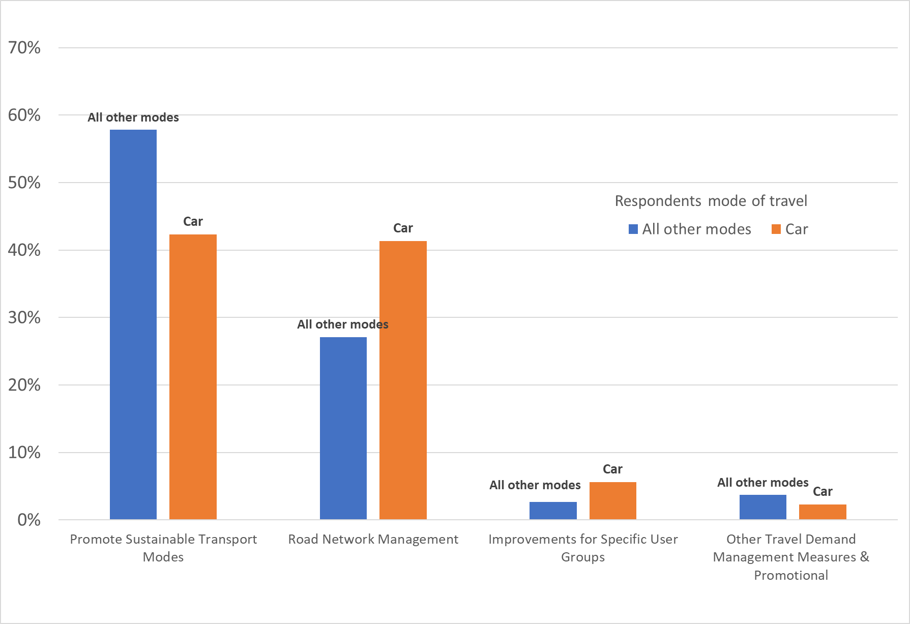

Other notable responses were comments calling for a greater focus on safer/lower speed roads around schools and promoting active travel for school children/students.

Another frequent comment was the wish to see tourist and special hire buses and coaches parking outside the central area and not adding to congestion and pollution inside in the city centre.

Figures 26 to 29 detail specific complementary measures that were mentioned by respondents grouped by each of the four main categories identified in Figure 25:

* Promote sustainable transport modes (Figure 26)
* Road network management (Figure 27)
* Improvements for specific user groups (Figure 28)
* Other travel demand management measures and promotional activity (Figure 29)

**Figure 26. Q33 - Specific Measures to complement traffic restrictions – Promote Sustainable Modes**

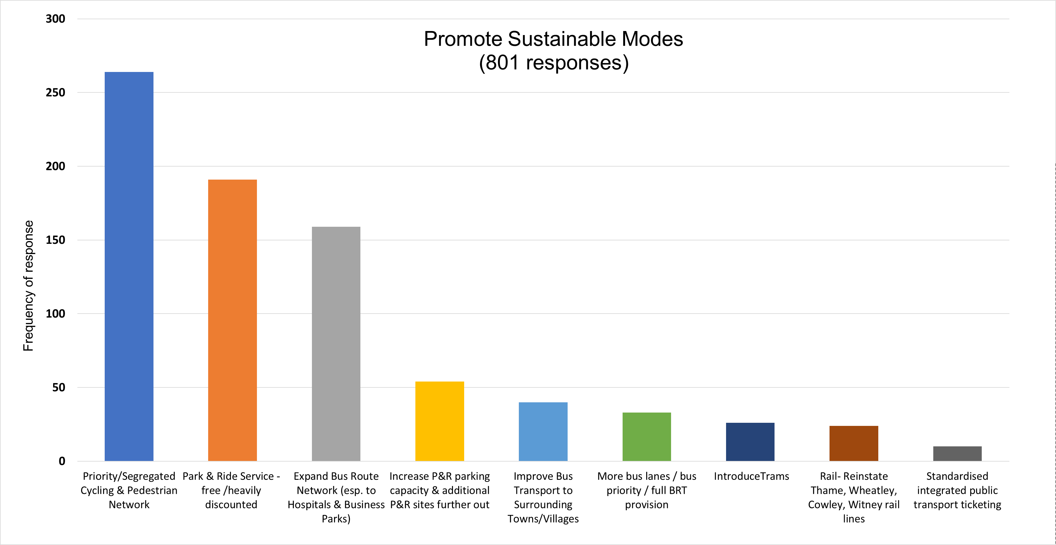

**Figure 27. Q33 - Specific Measures to complement traffic restrictions – Improvements to Road Network Management**

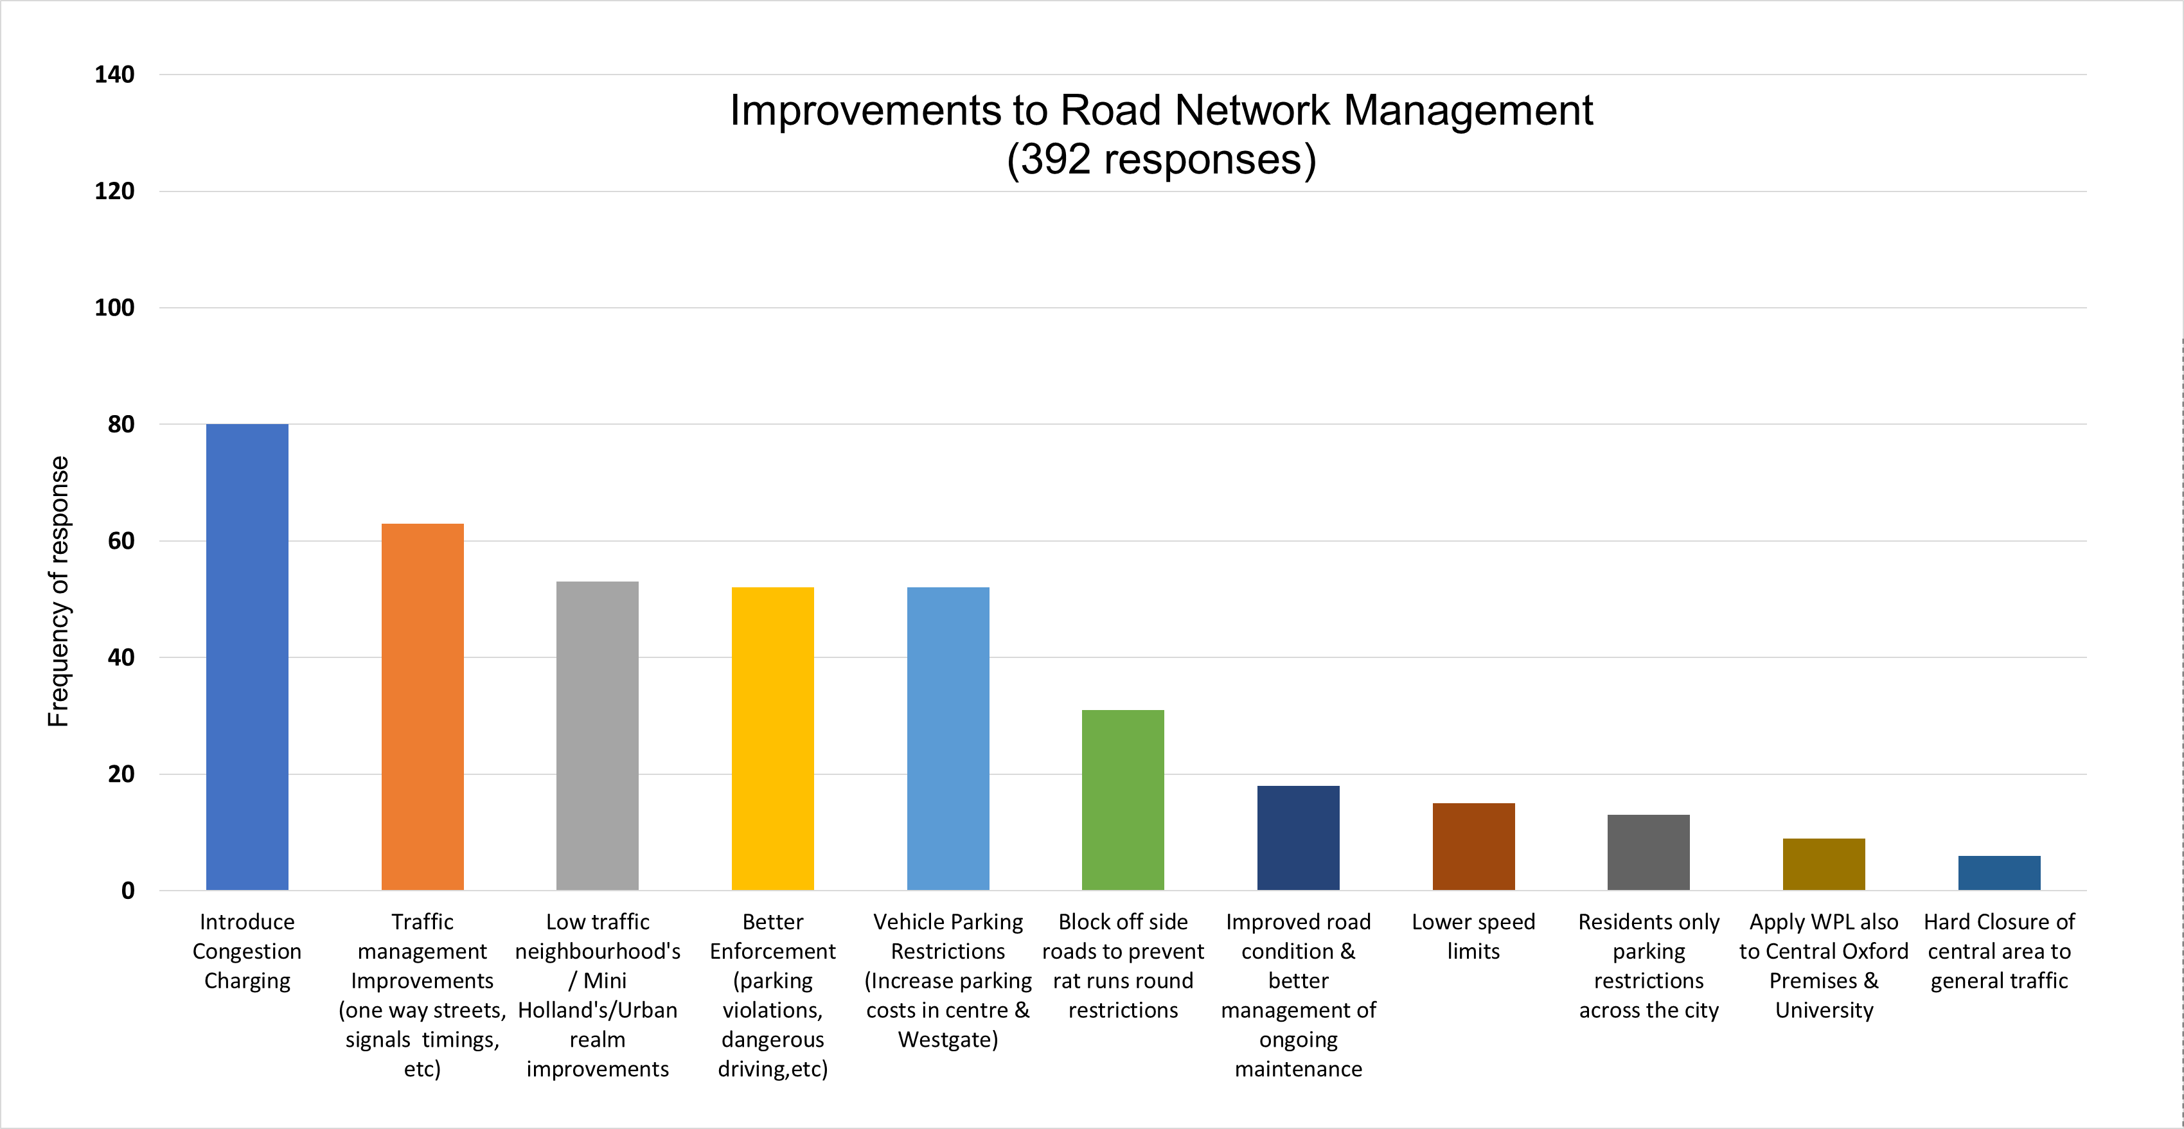

**Figure 28. Q33 - Specific Measures to complement traffic restrictions – Improvements for specific user groups**

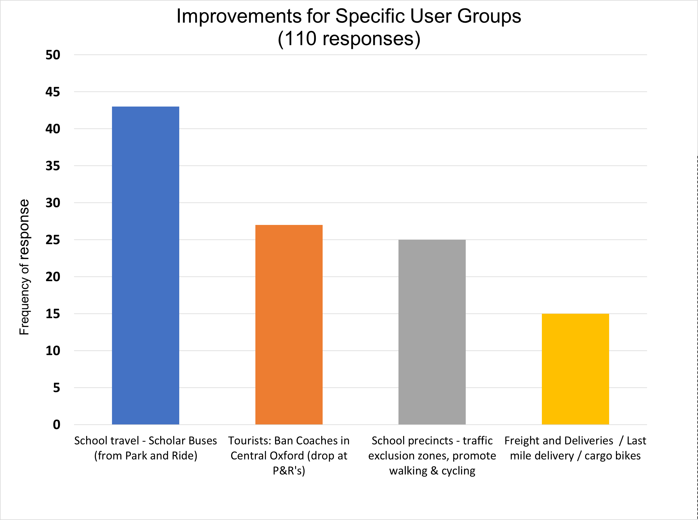

**Figure 29. Q33 - Specific Measures to complement traffic restrictions – Other Travel Demand Management Measures & Promotional Activity**

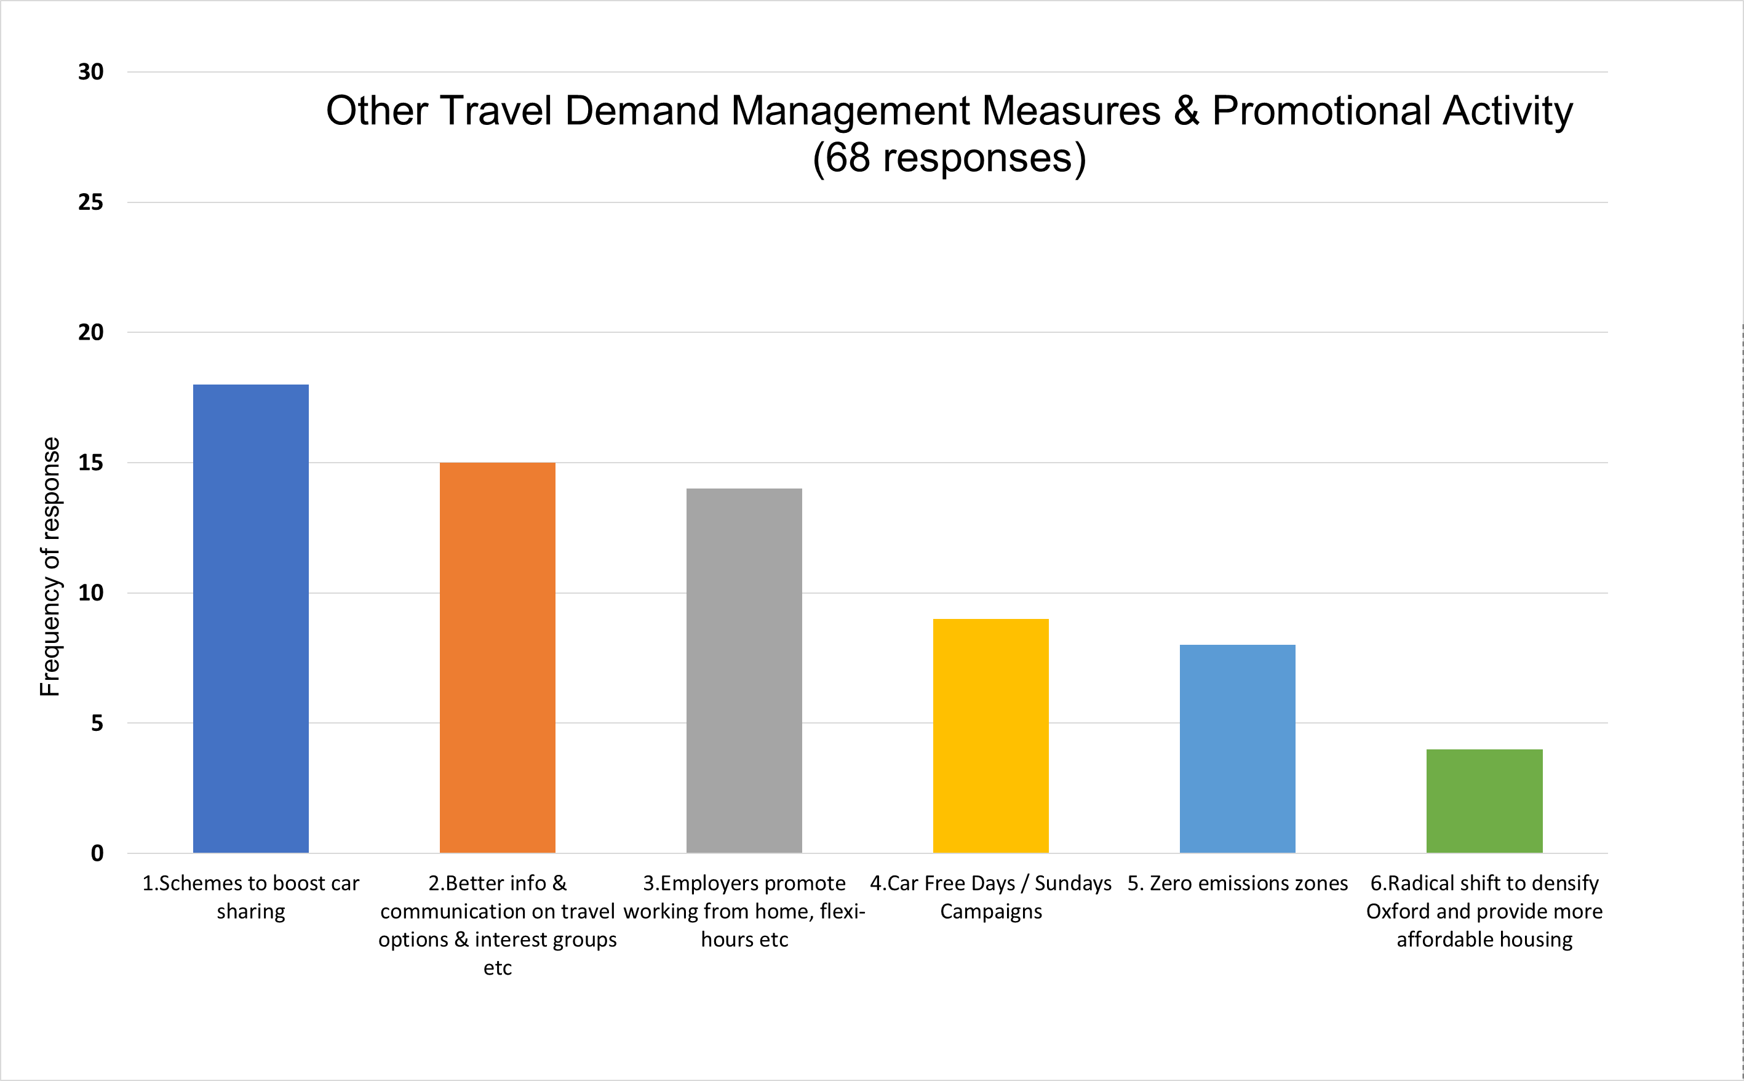

**Q34. Are the suggested traffic restrictions in the right places?**

The responses to the first part of the question *“Are the suggested traffic restrictions in the right places?”* is shown in Figure 30 below. The 595 responses recorded were evenly split between those whose main mode of travel is car, bike and those using public transport.

In total, for all modes taken together, there are more responses that voice disagreement with the proposed placement of traffic restrictions than responses in general agreement with the proposed locations. There is a contrast when comparing between respondents in terms of their main mode of travel. Of the responses made from those travelling by car there are many more disagreeing with the locations of restrictions and/or being against the restrictions generally as compared to car users in agreement. In contrast, responses for those travelling by bicycle, there were twice the number in agreement with the locations to those having some disagreement.

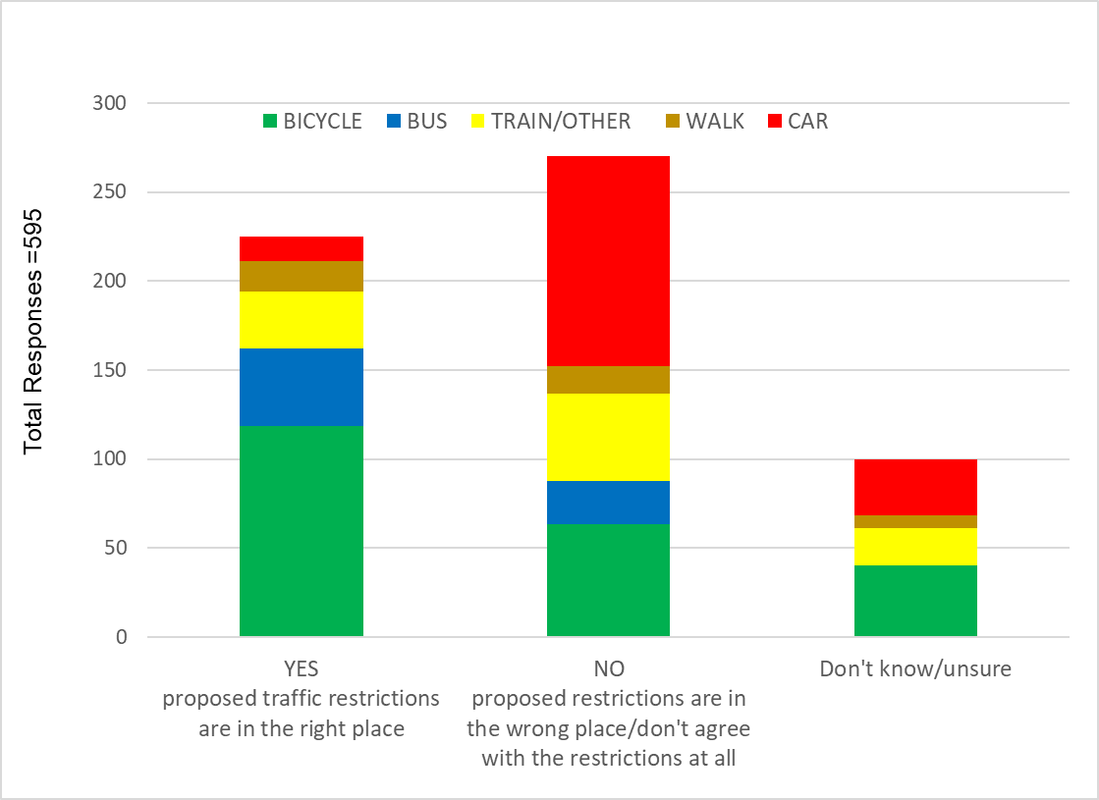**Figure 30 – Are the traffic restrictions in the right place? (Q34)**

Of the 353 recorded responses proposing additional roads to be included in the traffic restrictions (see Figure 31), 63% came from people who cycle as their main mode of travel.

**Figure 31 – suggestions for additional traffic restrictions (Q34)**

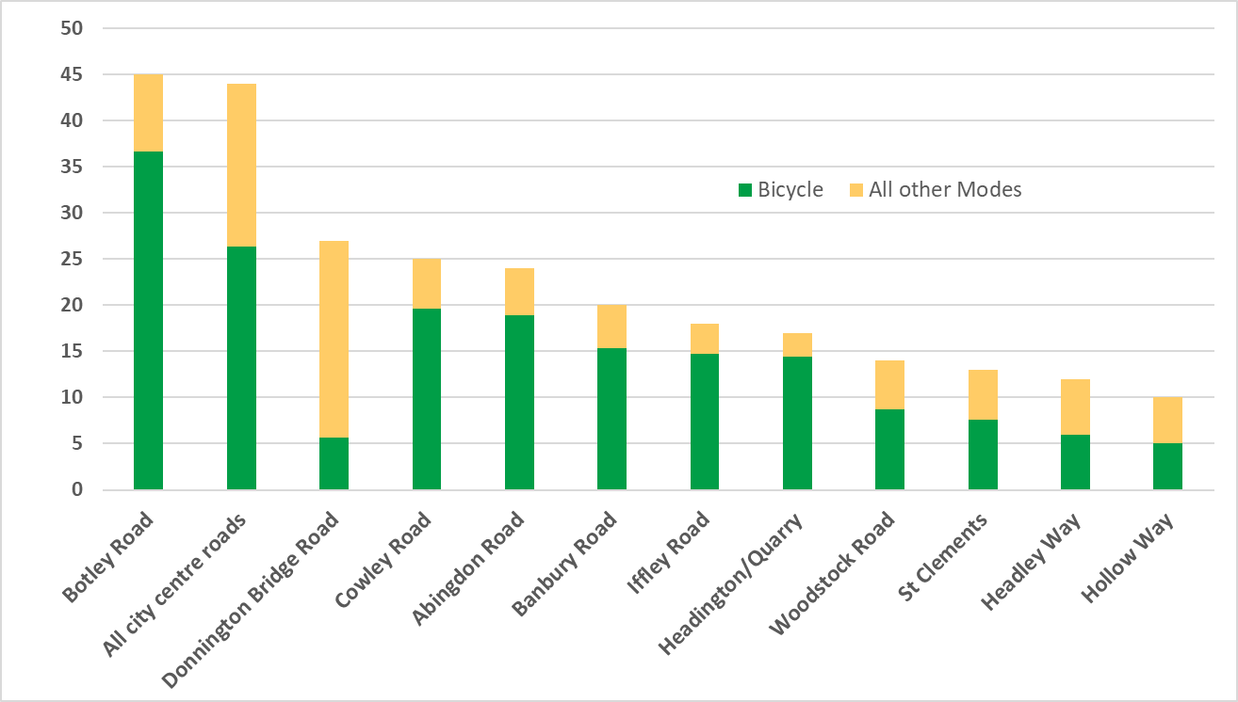

Figure 32 shows respondents’ suggestions regarding roads to be excluded from restrictions. The most requested change was for Marston Ferry Road, a view shared by car users, public transport users and cyclists. The general opinion being that traffic would be displaced outwards onto an already congested ring road and result in a worse situation overall. The comment was frequently made that planned increases in bus services will not in the short to medium term be sufficient to create the balance. There were also numerous comments, mainly from car-as-main-mode respondents requesting Hollow Way to be excluded as it would prevent local resident access.

**Figure 32 – Suggestions for roads not to be included in the traffic restrictions**

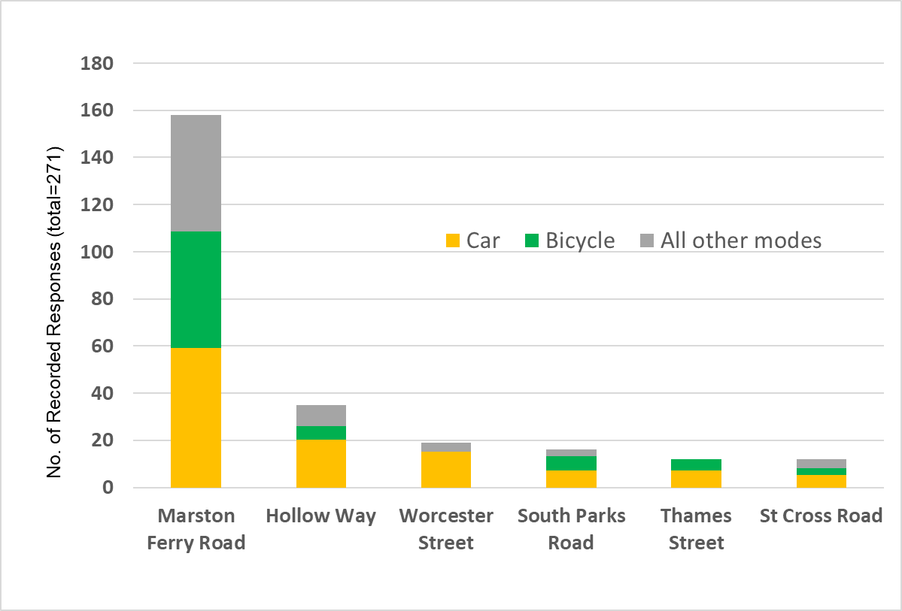

**Q35. Should employers who provide 10 or fewer commuter car parking spaces be exempt from the workplace parking levy?** **Should there be other exemptions?**

There was a total of 873 recorded responses to the question of whether the proposal for employers who provide 10 or fewer commuter car parking spaces to be exempt was right:

* 315 (36%) indicated there should no exemptions, suggesting that even employers who provide 10 or fewer spaces should be in scope
* 87 (10%) stated there should only be exemptions for employers providing 5 or fewer employee parking spaces
* 269 (31%) of responses agreed that the proposal of 10 or less spaces being exempt was appropriate.

There was a total of 692 responses to the question of whether anyone else should be exempt from the workplace parking levy. The most frequent responses in order were a) hospital staff b) blue badge holders/ disabled persons and c) school staff (teachers). See figure 33 below.

**Figure 33 - Q35 - Should Anyone Else be Exempt from the WPL**

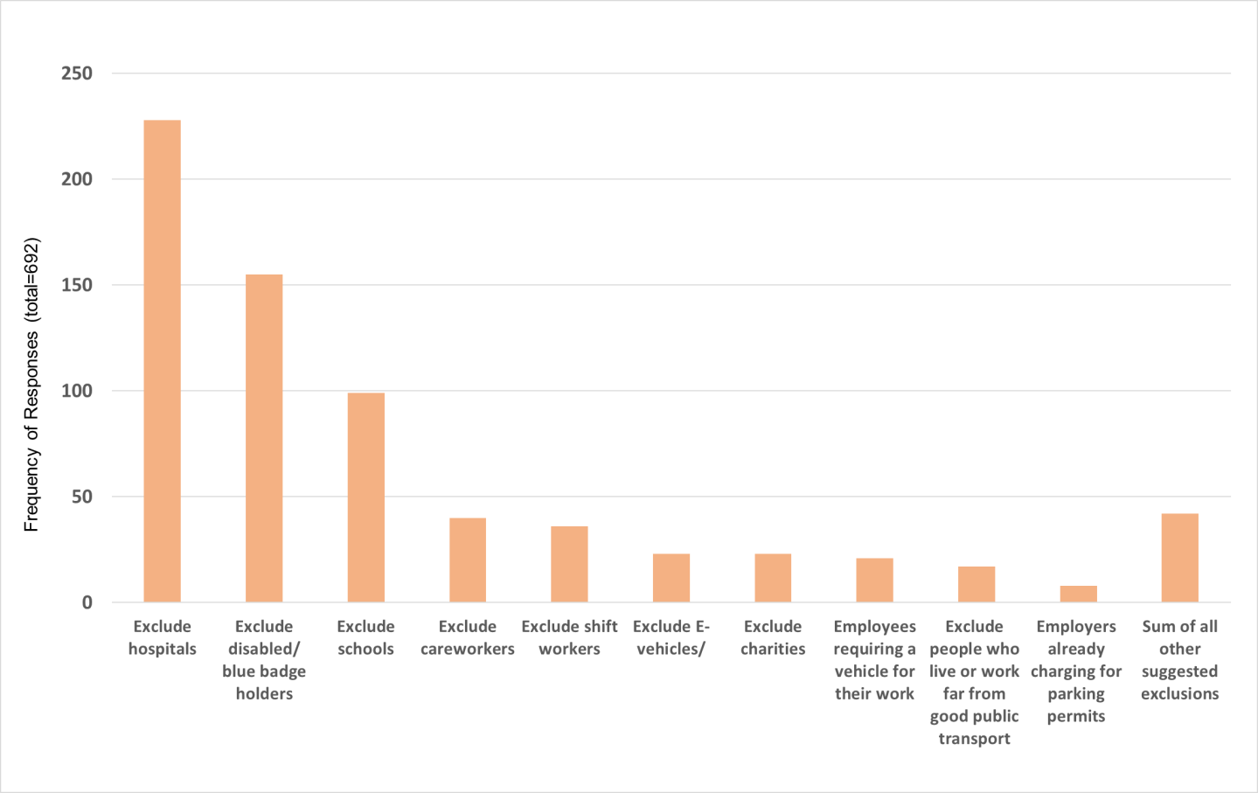

**Q36 - views on the proposed boundary of the Eastern Arc workplace parking levy.**

Responses to this question were categorised into two groups a) those commenting on the location of the proposed boundary and b) all other comments. The results are presented in figures 34 and 35 below.

**Figure 34 – what is your view on the proposed WPL area boundary? (Q36)**

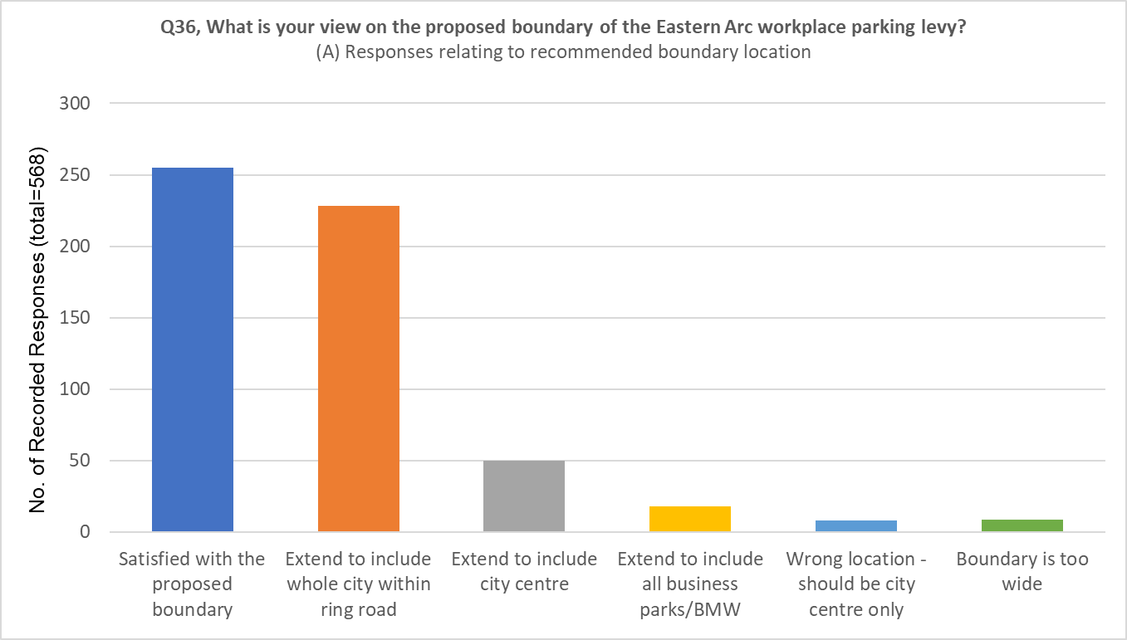

568 comments were recorded on the boundary position, see figure 34 above, with a slight majority satisfied with the proposed boundary. A large proportion also indicated that that the boundary should be extended further within the ring road.

**Figure 35 – responses to Q36 of those not currently supporting WPL**

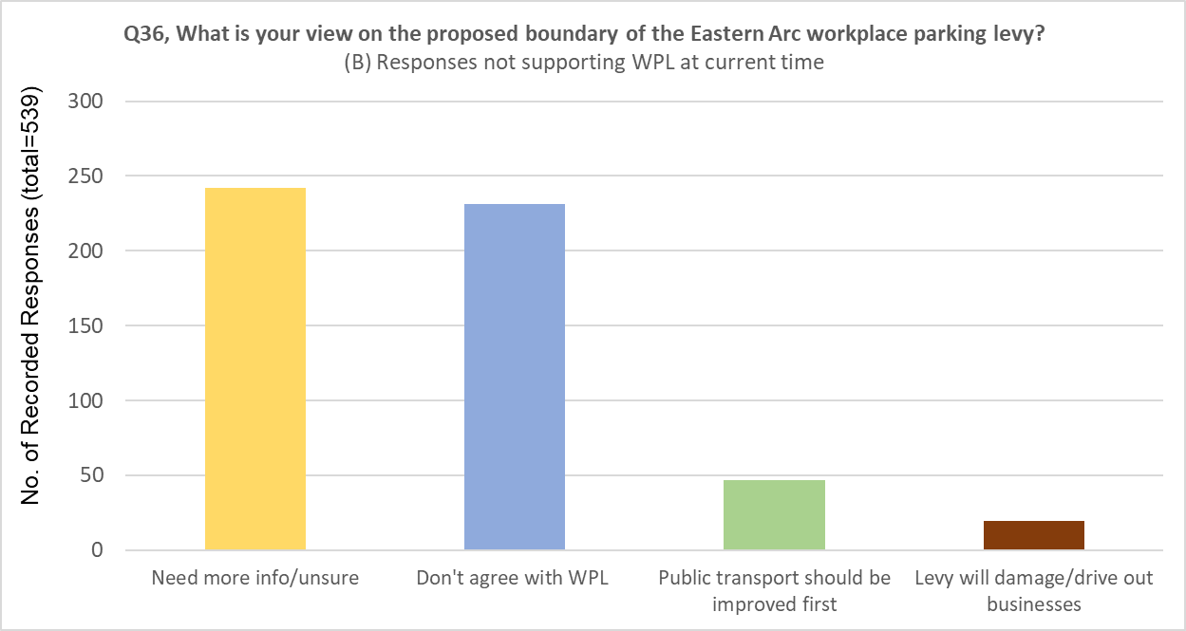

Of the other responses, i.e. those which did not relate to the location of the boundary, (539 responses) these were mostly a balance of respondents needing more information to be able to comment and those not agreeing with the WPL introduction. In addition, a significant number of respondents commented that public transport should be improved significantly before a WPL is introduced.

**Q37. Views on the level of charge for the workplace parking levy? £400 - 600 per parking space per year is the suggested level.**

1354 respondents (46%) provided a comment on this question. Of the responses, 783 were categorised as they directly responded to the question, and as shown in Figure 36, 320 of these agreed with a WPL set somewhere between £400 and £600, 115 suggested £400 or less while 205 suggested a level of £600 or above.

Of the 1354 responses, 25% indicated that they were not in support of a workplace parking levy and a further 13% were not sure what level to suggest.

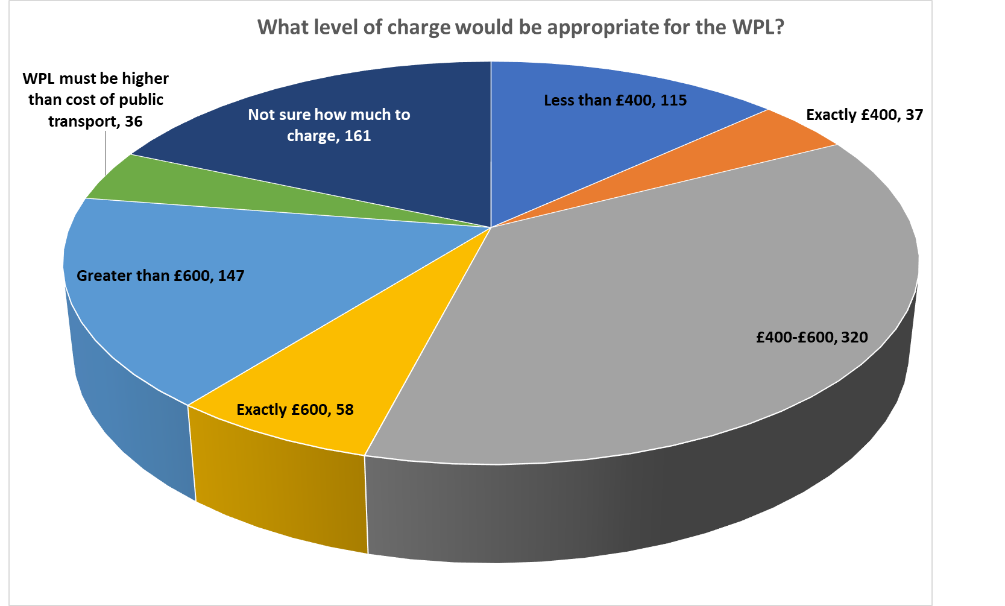**Figure 36 - Responses to Q37**

**Q38. Views on the suggested bus routes and employer/employee benefits that could be funded through the workplace parking levy, and whether the levy should be used to fund any other transport improvements.**

There was an overall 47% response rate to Q38, totalling 1384 respondents. The question posed was tiered asking a) for views on the proposed use of WPL funds and b) if the respondent had suggestions for funding other transport improvements.

Only a small percentage of respondents specifically commented on the suggested bus routes and employer/employee benefits. Of those that did, 70% expressed general agreement on the proposals.

1521 other suggestions were made for how the levy could be used. The top three suggestions were:

* Develop priority/segregated cycling network and comprehensive cycling promotion
* Expansion and intensification of bus service network (including non-radial routes and to hospitals and business parks)
* Free or strongly subsidised bus and Park & Ride services

These most recorded responses mirror the analysis of Question 33 (What other complementary schemes would you like to see for the traffic restrictions).

The following chart illustrates these responses grouped according to the main mode of travel of the respondent.

**Figure 37 - Responses to Q38 grouped according to main mode of travel of respondent**

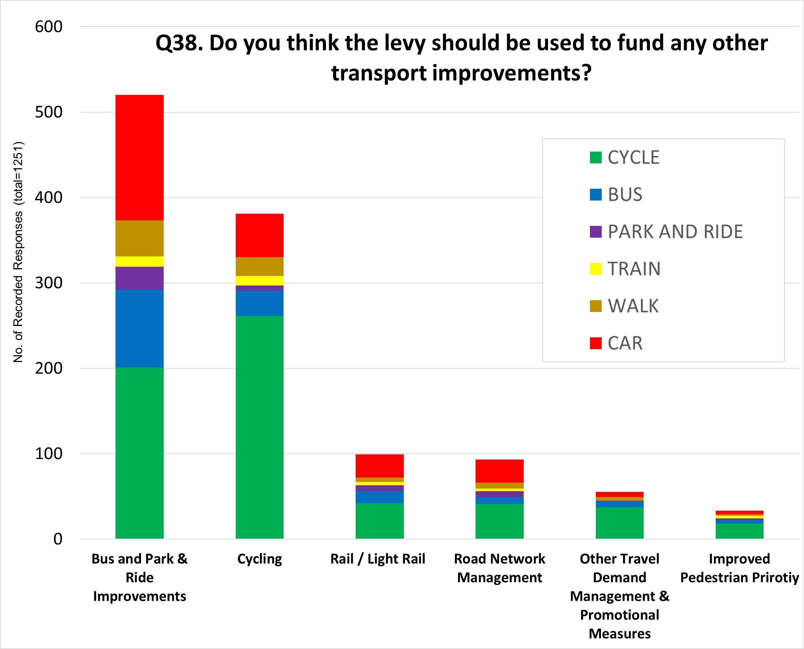

**Q39. If you'd like to make any other comments before you finish, please do so here**

1235 respondents provided further comments. A further 32 individuals submitted comments by email or letter. These range of responses have been plotted in Figure 38. These follow a similar pattern of feedback throughout the open questions in the online survey. The interventions most requested are listed as follows:

* The need to focus more on the expansion of the cycling network to prioritise road space to promote safe, well connected routes
* Expansion and intensification of the bus network to serve more trip needs, especially poorly served and isolated surrounding settlements.

**Fig 38. Representation of responses to Q39, Any Other Comments?**

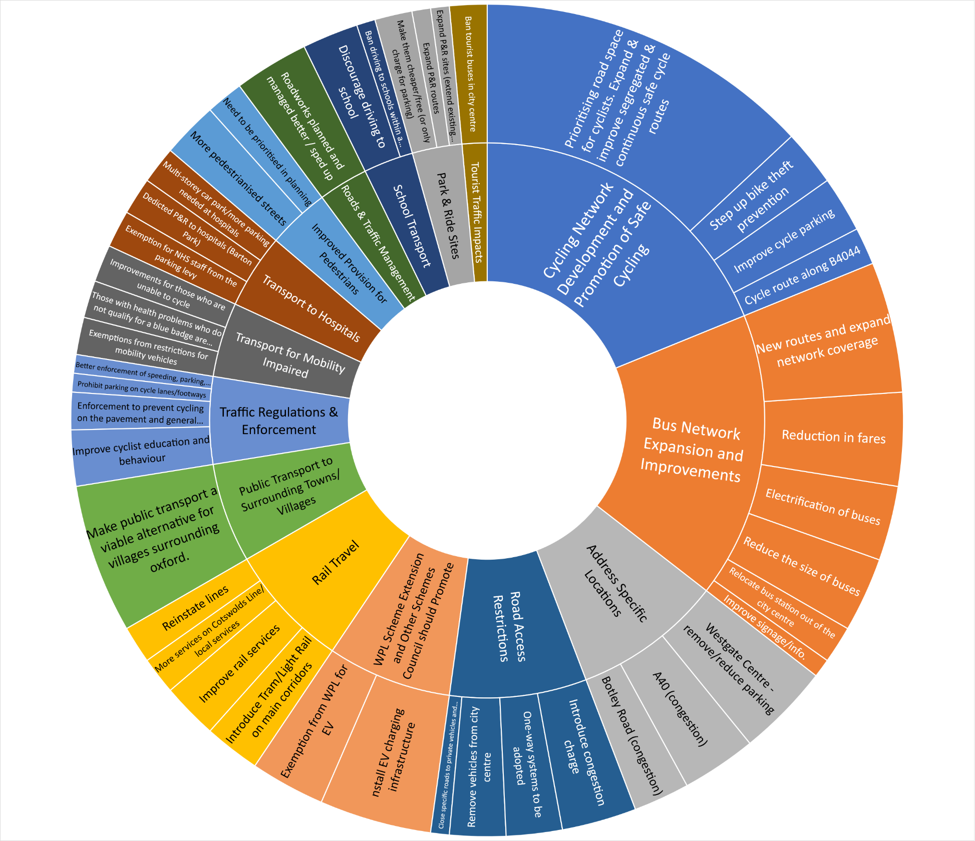

**Stakeholder/organisation letter and email comments**

The following 45 stakeholder groups and organisations submitted responses by email or letter in addition to or instead of completing the questionnaire.

*Arlington, Bicester Town Council, Brasenose College, Bullingdon Community Association, Centre for Research into Energy Demand Solutions, Chilton Parish Council, CoHSAT (Coalition for Healthy Streets and Active Travel), Cowley Area Transport Group, Cyclox, East Hendred Parish Council, Freeland Parish Council, Freight Transport Association, Friends of Old Headington, Headington Action, Holiday Inn Express Hotel, Hollow Way Medical Centre, Iffley Vets, Magdalen College School, Oxford Biomedica, Oxford Bus Company, Oxford City and County Bowls Club, Oxford City Cycling UK, Oxford City Economic Growth Board, Oxford Civic Society, Oxford Pedestrians Association, Oxford Schools Bus Partnership, Oxfordshire County Council Liberal Democrats Group, Oxfordshire Cycling Network, Oxfordshire Green party, Oxfordshire National Pensioners Convention Group, Oxford University Conference of Colleges, Oxford University Hospitals NHS Trust, POETS (Planning Oxfordshire’s Environment and Transport Sustainably), Rewley Park Management Company, ROX (Rescue Oxford), St John Street Area Residents’ Association, St Margaret’s Road Summertown Neighbourhood Forum, South Oxfordshire District Council, SPADE (Sunningwell Parishioners Against Damage to the Environment), Stagecoach in Oxfordshire, Thomas White Oxford, University of Oxford, Vale of White Horse District Council, Watlington Parish Council, Wolfson College*

The following is a brief summary of the most common raised issues in the non-questionnaire stakeholder responses.

**General support for the proposals**

Whilst some concerns were expressed, the majority of the organisations that submitted non questionnaire responses expressed general support for the objectives of Connecting Oxford albeit many of these did so in the context of needing further detail of how the proposals had been arrived at and what impact they would have.

**More information**

Most respondents want to see more information on the practical implications of the proposals, in terms of how effective they would be in reducing traffic and improving conditions for non-car alternatives. One of the most common themes in relation to the need for more information was how much traffic displacement there would be (mainly as a result of the traffic restriction points) on alternative routes, especially Oxford’s radial routes and ring road. There was concern that the proposals could simply move congestion problems around, possibly even exacerbating existing problems.

There were also queries regarding how much revenue the WPL proposals would raise and whether it would be enough to pay for the bus services and non-car infrastructure needed to create travel behaviour change.

There was strong support for the councils to undertake traffic modelling to help better understand how the proposals would influence travel across the city. This would therefore help to refine the details of the proposals. Suggestions were made by some about how the modelling should be carried out.

**Stakeholder input to development of the proposals**

Some organisations said they would like to be involved in shaping the proposals as they develop. This includes those that have large numbers of staff and hold lots of detailed information about how they currently travel to and around the city.

**WPL coverage**

It was suggested by many resident, transport and planning groups, and employers that the WPL should apply across the whole city. Covering only the proposed area of the Eastern Arc is considered by some to be inequitable and not sufficiently effective in reducing traffic volumes and influencing behavioural change. It was also frequently suggested that every parking space used for commuting should be covered by the WPL and not just those where workplaces had 11 or more. Concern was expressed about concentrations of employment that generate large volumes of traffic and congestion but which are not in scope of the WPL.

**Unfair WPL and impact on businesses**

A number of businesses felt that the WPL would be an unfair charge for local businesses who already contribute to the local economy by way of business rates. Queries were raised about why certain areas of the city including beyond the ring road would not be in scope for the WPL.

Businesses and schools were concerned that the introduction of a WPL would have an unhelpful negative impact on staff recruitment and retention – it is already difficult to attract staff to jobs in the city.

**Why not a congestion charge?**

There was a call for more information/explanation as to why the use of a congestion charge was not being proposed. A number of respondents felt that a congestion charge would be more effective and equitable than a WPL. Not least because it would affect all car journeys and not just those that ended at a parking space in the Eastern Arc.

More broadly, respondents want to know what other approaches were considered and why they were rejected.

**Space filled up with new journeys?**

Concerns were expressed about how reducing traffic and congestion may simply attract other journeys by car that people were not making previously because of the delay that they were subject to. Measures should be put in place to prevent new space simply being filled up again with new vehicle journeys. The use of a congestion charge in addition to the traffic restriction points was one suggestion for how this issue can be addressed.

**Potential for more displaced traffic/rat running – more traffic restrictions needed**

A wide range of different respondents raised concerns that the proposals could result in traffic displacement to parts of the network that may or may not already be congested. Others were concerned that traffic restriction points could cause more rat running including through residential areas for example Donnington Bridge Road, the roads between Iffley and Cowley Roads and also in the Headington, Old Headington, Northway and Marston areas of the city. Some felt that Iffley Road and St Clements could become a new alternative route for journeys to and from the Marston and Headington areas. As such additional traffic restriction points were suggested to tackle this for example St Clements, Donnington Bridge Road, various residential streets.

**Timing of traffic restriction points**

A range of opinions were given on when traffic restriction points should operate. Some felt that they should be in use all the time whereas others argued that they are only needed when there is congestion i.e. morning and evening peak periods during the week. Some groups felt that if they operate only at peak times this would have less of a negative impact on necessary local trips by people who need to use the car.

**Exemptions for traffic restriction points**

A range of opinions were expressed on this point with many saying that very limited exemptions should be given for use of the traffic restriction points in order to ensure their effectiveness. Of these, it was widely suggested that only buses, taxis and private hire vehicles should be allowed. Some felt that there may be a case for allowing vehicles making essential deliveries and carrying out servicing and repairs etc, particularly in the case of city centre restriction points or generally for properties very close to the restriction points. In some instances, resident groups and providers of healthcare services made a case for allowing people living close to traffic restriction points to be allowed to pass through them to avoid long detours for essential journeys.

There was a general feeling that electric vehicles shouldn’t be exempt from the traffic restrictions given their impact on traffic congestion.

It was highlighted that private buses/coaches taking children to schools in the city should be allowed to use the traffic restriction points as they help tackle the negative impacts of the school run.

**Oxpens traffic restriction point/Access to Westgate**

It was highlighted that the exact location of the traffic restriction point on Oxpens would influence how traffic approaches the Westgate car park – west of the car park would require all traffic getting there to route via Abingdon Road. East of the entrance would require all traffic to route via Botley Road. This could put excessive pressure on either of those routes.

**Introduction of non-car alternatives/timing of scheme start**

Many stakeholders emphasised that measures to encourage and cater for non car alternative modes of transport must be in place on day one of the scheme being operational.

**Expanded 20mph speed limit**

A number of respondents were concerned that if the measures are effective in reducing traffic then a 20mph speed limit on all the city’s roads would be needed to ensure attractive conditions for cyclists and pedestrians.

**Wider Controlled Parking Zones (CPZs) coverage needed**

It was frequently suggested that greater coverage of the WPL area by CPZs would be needed to prevent people from parking in residential areas rather than changing to non-car modes of travel. Any such wider CPZ coverage would be needed in time for the start of the WPL.

**Removal of bus lanes**

There was some concern expressed about the suggestion that traffic reduction could lead to removal of bus lane provision. This would only be acceptable if there was clear evidence that buses would not be affected by congestion in the future. It was considered that some busy junctions would continue to need priority for buses at least into the foreseeable future.

**Improvements to the public realm**

A number of organisations were keen to point out that traffic restriction points would offer opportunities in the vicinity to improve the quality of the public/civic realm.

**New bus routes**

Building on the proposals in the engagement material, there were a number of suggestions, some very detailed, about how bus services into and across the Eastern Arc could be improved to give better access to key destinations.

**Improved cycle infrastructure**

Ideas were given for how to improve cycling facilities, some general and some specific ideas. There was strong support for proper segregation of cyclists from vehicles and pedestrians. It was also said that high quality connections are needed from origins outside of the city.

**Impact of school run**

It was said several times that unlike a congestion charge, the WPL would have a limited impact on the congestion associated with school runs, not least because many of these trips do not end in the car being parked.

**Tourist coaches**

Some concern was expressed about the impact that the proposals might or might not have on coaches bringing tourists to the city centre. Practically speaking queries were raised about how coaches would turn around if they weren’t allowed through traffic restriction points. Others were concerned that a WPL would not have sufficient effect on the negative impacts of tourist coaches.



# Connecting Oxford

# Feedback survey

This is a printable version of an online survey, available at:

<https://www.smartsurvey.co.uk/s/60ZY3/>

**Please complete the survey online if you can.**

Paper survey forms can be posted or hand delivered to:

Connecting Oxford

Oxfordshire County Council

County Hall

New Road

Oxford

OX1 1ND

This is **not** a freepost address.

Welcome.  
  
We're suggesting some bold ideas to improve connectivity, reduce congestion and tackle pollution in and around Oxford.  We need your views on them to help us develop the proposals.

|  |
| --- |
| Please [read the Connecting Oxford brochure](http://www.oxfordshire.gov.uk/sites/default/files/file/roads-and-transport-connecting-oxfordshire/connecting_oxford_brochure.pdf) before completing this questionnaire. ​ |

This survey asks for your personal data. To find out how we handle your data please visit the webpage below or write to us at the address above.

<https://www.oxfordshire.gov.uk/council/about-your-council/access-data-and-information/data-subject-rights>

**About you**

**1. I am completing this survey:**

|  |  |
| --- | --- |
|  | In a personal capacity – **please go to question 6** |
|  | As a representative of a business, employer or other organisation |

**About you and your organisation**

**We will assume your responses represent the views of your organisation.**

**If you are responding in a personal capacity, please go to question 6**

**2. Which business, employer or organisation are you representing?**

|  |
| --- |
|  |

**3. What is your name?**

|  |
| --- |
|  |

**4. What is your role in the organisation you are representing?**

|  |
| --- |
|  |

**5. If you would like to receive updates about this project in future, please enter your email address:**

|  |
| --- |
|  |

**More about you**

**6. What's your home postcode? We need this to understand how views might be shaped by where people live. We cannot identify you personally from your postcode, and it will be used only to analyse the responses to the survey.**

|  |
| --- |
|  |

**7. If you would like to receive updates about this project in future, please enter your email address:**

|  |
| --- |
|  |

**More about you**

**8. It would help us when analysing the feedback from the survey to know more about you. These questions are all optional, so you can skip this section if you want to.**

|  |  |
| --- | --- |
|  | I'm happy to provide more information about myself |
|  | I'd like to skip to the next part of the survey – **please go to question 18** |

**More about you**

**All information given is anonymous and any information provided is governed by the General Data Protection Regulations 2018. All information given will be treated as strictly confidential.**

**9. Are you:**

|  |  |
| --- | --- |
|  | Male |
|  | Female |
|  | Prefer not to say |
|  | Other (please specify):   |  | | --- | |  | |

**10. What is your age group?**

|  |  |
| --- | --- |
|  | Under 11 |
|  | 12 – 17 |
|  | 18 – 24 |
|  | 25 – 34 |
|  | 35 – 44 |
|  | 45 – 54 |
|  | 55 – 64 |
|  | 65 – 74 |
|  | 75 – 84 |
|  | 85 plus |

**11. Please describe your marital status. Leave blank if you wish.**

|  |
| --- |
|  |

**12. Please describe your ethnic group or background. Leave blank if you wish.**

|  |
| --- |
|  |

**13. Please describe your religion. Leave blank or write none if appropriate.**

|  |
| --- |
|  |

**14. Do you have a disability? Please say no, or say yes and briefly describe it if you wish. Or you can leave blank, or write prefer not to say.**

|  |  |
| --- | --- |
|  | Yes |
|  | No |

Comments:

|  |
| --- |
|  |

**15. Are you currently pregnant or have you been pregnant in the last year?**

|  |  |
| --- | --- |
|  | Yes |
|  | No |
|  | Prefer not to say |

**16. Do you consider yourself to be...**

|  |  |
| --- | --- |
|  | Heterosexual or straight |
|  | Gay or lesbian |
|  | Bisexual |
|  | Prefer not to say |
|  | Other (please specify if you wish):   |  | | --- | |  | |

**17. Is your gender identity the same as the gender you were assigned at birth?**

|  |  |
| --- | --- |
|  | Yes |
|  | No |
|  | Prefer not to say |

**Thank you for answering these additional questions.**

**Your travel**

**These questions are about how you travel in and around Oxford.**

**If you are responding on behalf of an organisation, please go to question 26**

**18. For what purpose do you most often travel in and around Oxford?**

|  |  |
| --- | --- |
|  | Commuting to and from work |
|  | Business travel whilst at work |
|  | Shopping, leisure or tourism |
|  | Visiting friends and family |
|  | Other (please specify):   |  | | --- | |  | |

**19. What is the postcode of your normal place of work (if applicable)?**

|  |
| --- |
|  |

**Your travel**

**20. Thinking about your main purpose for travelling in Oxford, how do you most often travel?**

|  |  |
| --- | --- |
|  | Bicycle |
|  | Bus |
|  | Car all the way to my destination |
|  | Motorcycle |
|  | Park & Cycle |
|  | Park & Ride (bus) |
|  | Park & Walk |
|  | Taxi |
|  | Train & Bus |
|  | Train & Cycle |
|  | Train & Taxi |
|  | Train & Walk |
|  | Walk |
|  | Other (please specify):   |  | | --- | |  | |

Why do you use this mode?

|  |
| --- |
|  |

**About your bus travel (if applicable)**

**21. Which bus service(s) do you most often use?**

|  |
| --- |
|  |

**Your priorities when travelling**

**22. What three things are most important to you when travelling in Oxford?**

**Please enter the numbers 1, 2 and 3 in the boxes below.**

**1 = most important**

**2 = second most important**

**3 = third most important**

**You can only enter numbers 1 -3. Please use each number only once, otherwise we can’t use your response and it won’t count towards our analysis.**

|  |  |  |
| --- | --- | --- |
| The reliability of my journey | |  | | --- | |  | |
| How safe I feel whilst travelling | |  | | --- | |  | |
| Being able to do something else (e.g. work or read) whilst travelling | |  | | --- | |  | |
| The impact of my journey on my health | |  | | --- | |  | |
| The impact of my journey on the environment | |  | | --- | |  | |
| Having a comfortable journey | |  | | --- | |  | |
| How long my journey takes | |  | | --- | |  | |
| How much my journey costs | |  | | --- | |  | |

Comments:

|  |
| --- |
|  |

**Your views on traffic restrictions**

**23. Based on your priorities, do you think the additional traffic restrictions we're suggesting would make your journeys better or worse overall?**

|  |  |
| --- | --- |
|  | Better |
|  | About the same |
|  | Worse |
|  | Don't know |

Why do you say that?

|  |
| --- |
|  |

**Your views on a workplace parking levy**

**24. Based on your priorities, do you think the workplace parking levy and the improvements it could pay for would make your journeys better or worse overall?**

|  |  |
| --- | --- |
|  | Better |
|  | About the same |
|  | Worse |
|  | Don't know |

Why do you say that?

|  |
| --- |
|  |

**Your ideas for other changes**

**25. Based on your priorities, could anything else be done to improve your journeys in Oxford?**

|  |  |
| --- | --- |
|  | Yes (please state below) |
|  | No |
|  | Don't know |

Comments:

|  |
| --- |
|  |

**Your organisation's priorities**

**If you are responding in a personal capacity, please go to question 30**

**26. What are your organisation's top three priorities for transport in and around Oxford?**

**The options relate to your organisation's staff commuting, business travel and goods/servicing requirements.**

**Please enter the numbers 1, 2 and 3 once in each COLUMN (A, B and C) below. Please use each number only once in each column, otherwise we can’t use your response and it won’t count towards any analysis.**

**1 = most important priority**

**2 = second most important priority**

**3 = third most important priority**

|  | Staff commuting to and from work | Business travel (excluding commuting) | Movement of goods and service vehicles |
| --- | --- | --- | --- |
| Reliability | |  | | --- | |  | | |  | | --- | |  | | |  | | --- | |  | |
| Safety | |  | | --- | |  | | |  | | --- | |  | | |  | | --- | |  | |
| Impact on fitness and health | |  | | --- | |  | | |  | | --- | |  | | |  | | --- | |  | |
| Impact on air pollution and climate change | |  | | --- | |  | | |  | | --- | |  | | |  | | --- | |  | |
| Journey comfort | |  | | --- | |  | | |  | | --- | |  | | |  | | --- | |  | |
| Journey times | |  | | --- | |  | | |  | | --- | |  | | |  | | --- | |  | |
| Transport costs | |  | | --- | |  | | |  | | --- | |  | | |  | | --- | |  | |

Comments:

|  |
| --- |
|  |

**Your organisation's views on traffic restrictions**

**27. Based on its priorities, does your organisation think the additional traffic restrictions we're suggesting would make transport in Oxford better or worse overall?**

|  |  |
| --- | --- |
|  | Better |
|  | About the same |
|  | Worse |
|  | Don't know |

Why do you say that?

|  |
| --- |
|  |

**Your organisation's views on a workplace parking levy**

**28. Based on its priorities, does your organisation think the workplace parking levy and the improvements it could pay for would make transport in and around Oxford better or worse overall?**

|  |  |
| --- | --- |
|  | Better |
|  | About the same |
|  | Worse |
|  | Don't know |

Why do you say that?

|  |
| --- |
|  |

**Your organisation's ideas for other changes**

**29. Based on your organisation's priorities, is there anything else that could be done to improve transport in Oxford?**

|  |
| --- |
|  |

**More detailed questions**

**You have reached the end of the main questions.**

**30. If you have time, would you like to answer a few more detailed questions? Depending on the length of your answers this may take another 10 minutes or more, but your answers will be very helpful.**

|  |  |
| --- | --- |
|  | Yes, I'd like to answer some more detailed questions |
|  | No thanks, I'd like to finish the survey – **please go to question 39** |

**Detailed questions - traffic restrictions**

**31. Should there be any exemptions for the traffic restrictions? If so, please explain why.**

|  |
| --- |
|  |

**32. At what times and on which days should the traffic restrictions be in force? Why?**

|  |
| --- |
|  |

**33. What other complementary schemes would you like to see for the traffic restrictions, and why?**

|  |
| --- |
|  |

**34. Are the suggested traffic restrictions in the right places? Please describe any changes you would like to see, and why.**

|  |
| --- |
|  |

**Detailed questions - workplace parking levy**

**35. We're suggesting that employers who provide 10 or fewer commuter car parking spaces would be exempt from the workplace parking levy. Do you think this is right? Should anyone else be exempt from the workplace parking levy? If so, please explain why.**

|  |
| --- |
|  |

**36. What is your view on the proposed boundary of the Eastern Arc workplace parking levy?**

|  |
| --- |
|  |

**37. What level of charge do you think is appropriate for the workplace parking levy? £400 - 600 per parking space per year is the suggested level.**

|  |
| --- |
|  |

**38. What is your view on the suggested bus routes and employer/employee benefits that could be funded through the workplace parking levy? Do you think the levy should be used to fund any other transport improvements?**

|  |
| --- |
|  |

**Any other comments**

**39. If you'd like to make any other comments before you finish, please do so here. We can't respond to individual questions raised here. If you have a question you'd like us to reply to, please write to us at the address above.**

|  |
| --- |
|  |

**Thank you for completing this survey.**